13-01-2023

What is CI/CD?

Used for Continuous Integration and Continuous Delivery of the code.

Eg: Jenkins, Azure Pipeline, GitHub Actions

JENKINS (Continuous Integration Tool)

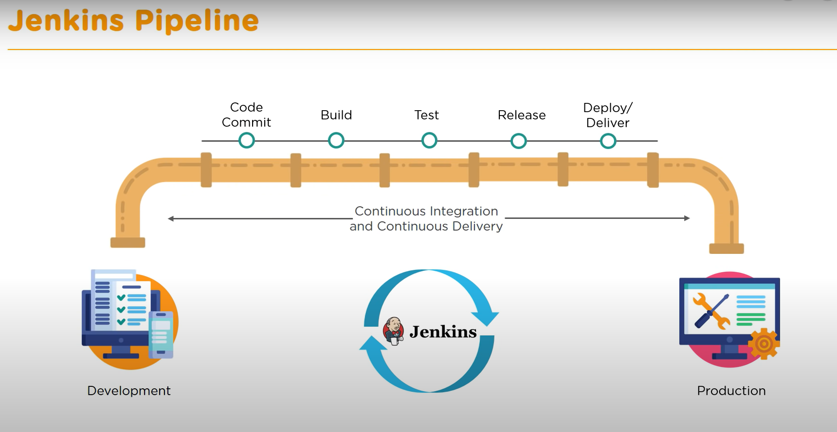

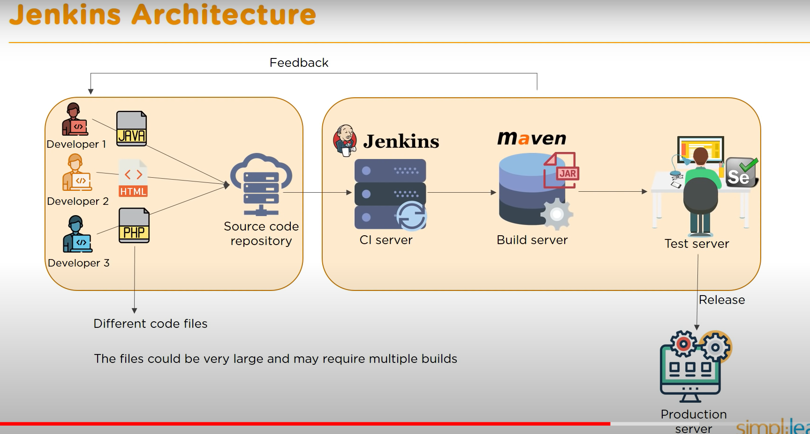

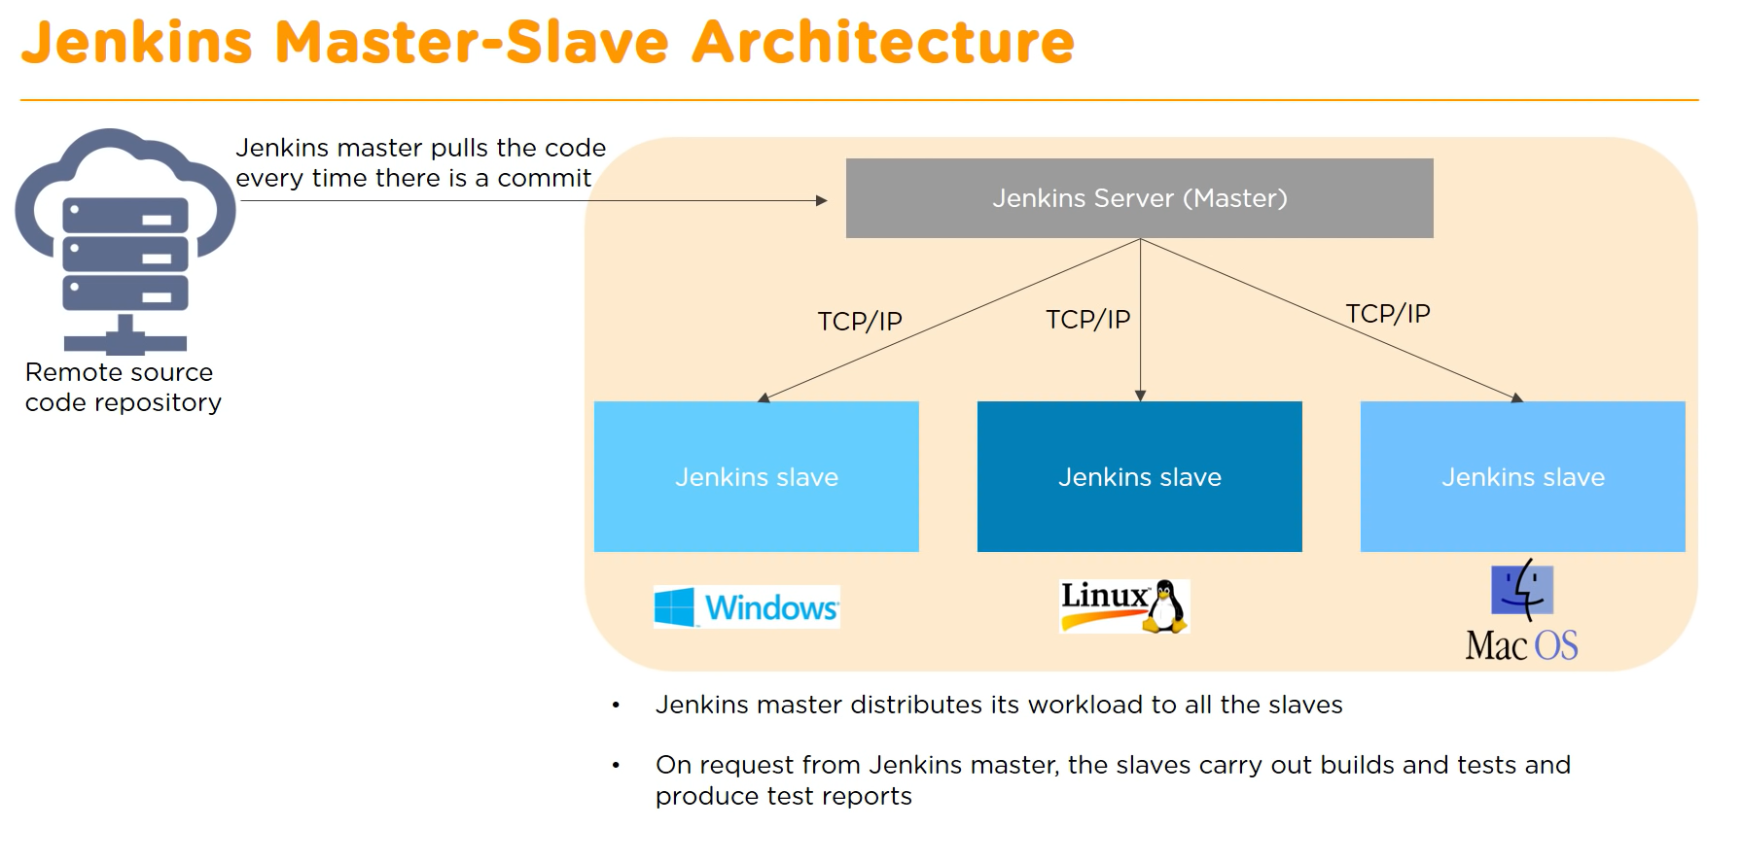

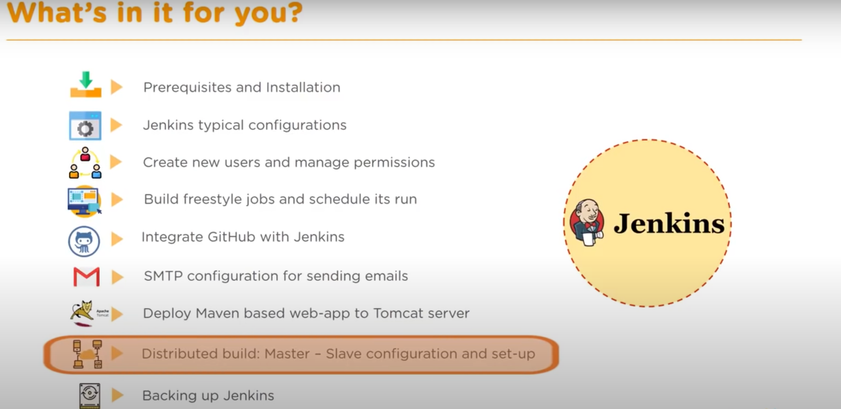

**How to install Jenkins?**

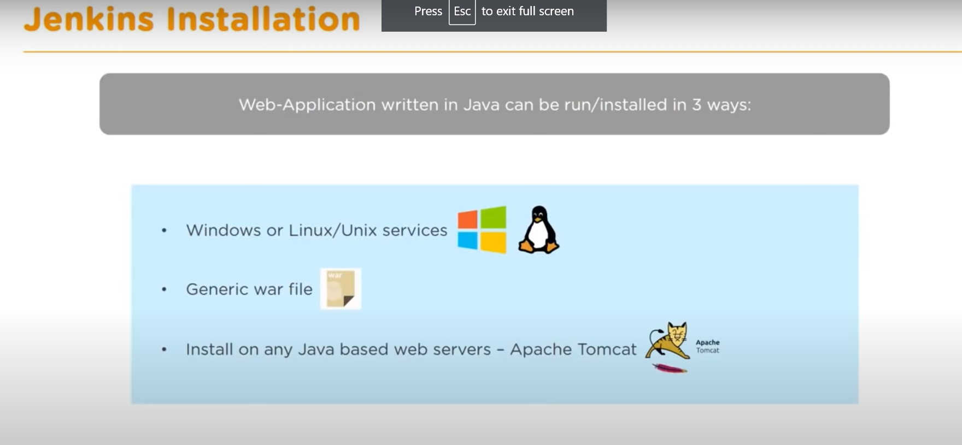

**Prerequisites of Jenkins**

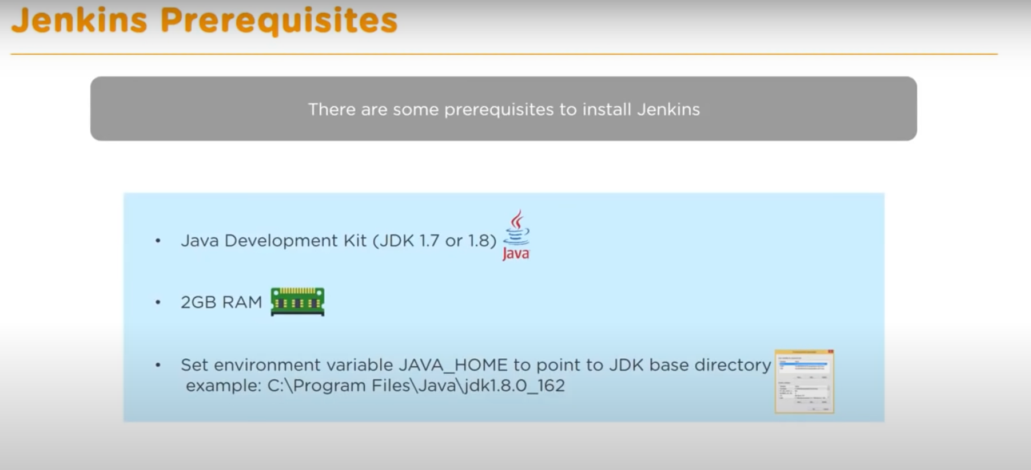

**Jenkins uses port 8080**

**How to configure email details for sending emails:**

Manage Jenkins > Configure System > SMTP Server details

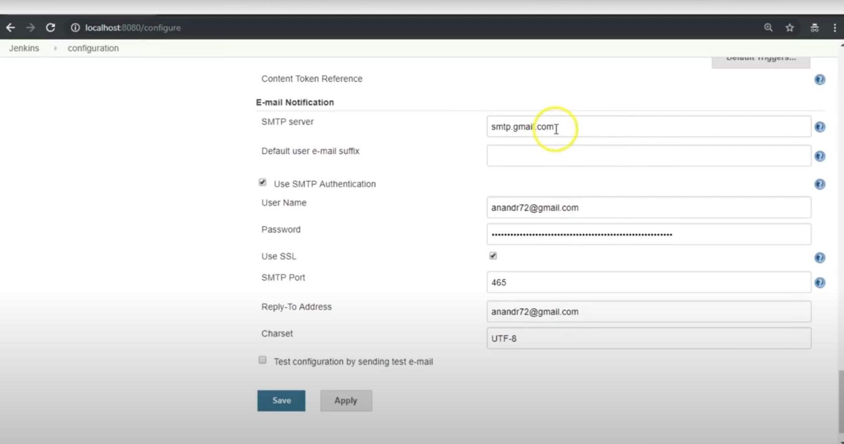

**Tool Configuration -> Specifying which software is to be used while using Jenkins**

Manage Jenkins > Tool Configuration > JDK

Provide /bin location of JDK from the installation location.

Set environment variable as JAVA_HOME and give the /bin location here as well.

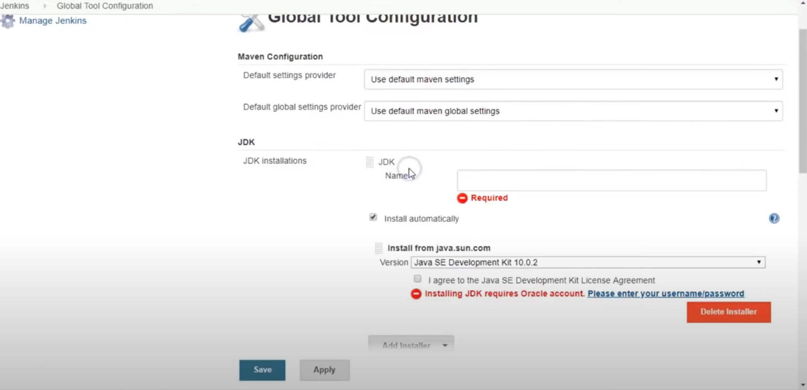

* **HOW TO BUILD A MAVEN PROJECT:**

1. Download Maven package and set the environment path variable.
2. Download Tomcat server package and set the environment path variable, also change the default port in “server.xml” as Tomcat uses 8080 and so does Jenkins.

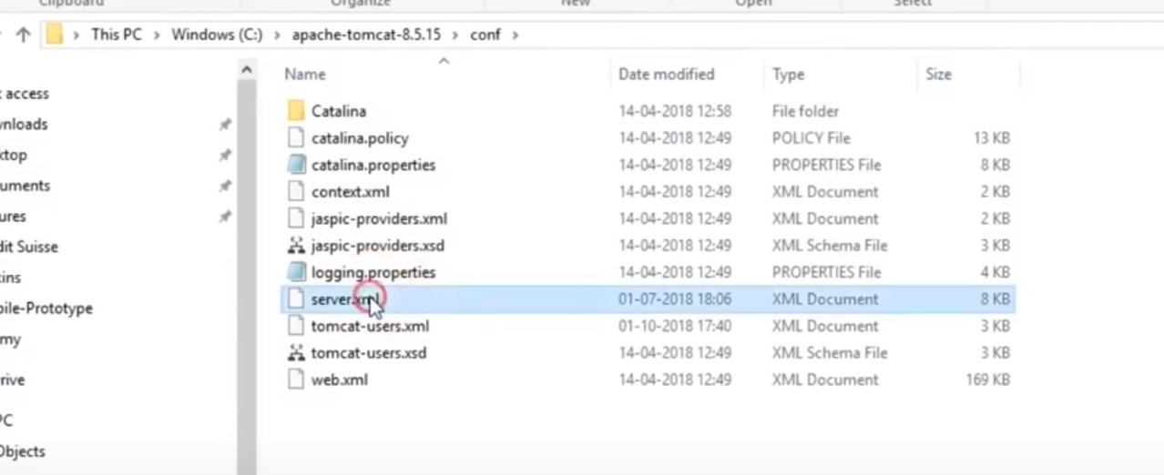

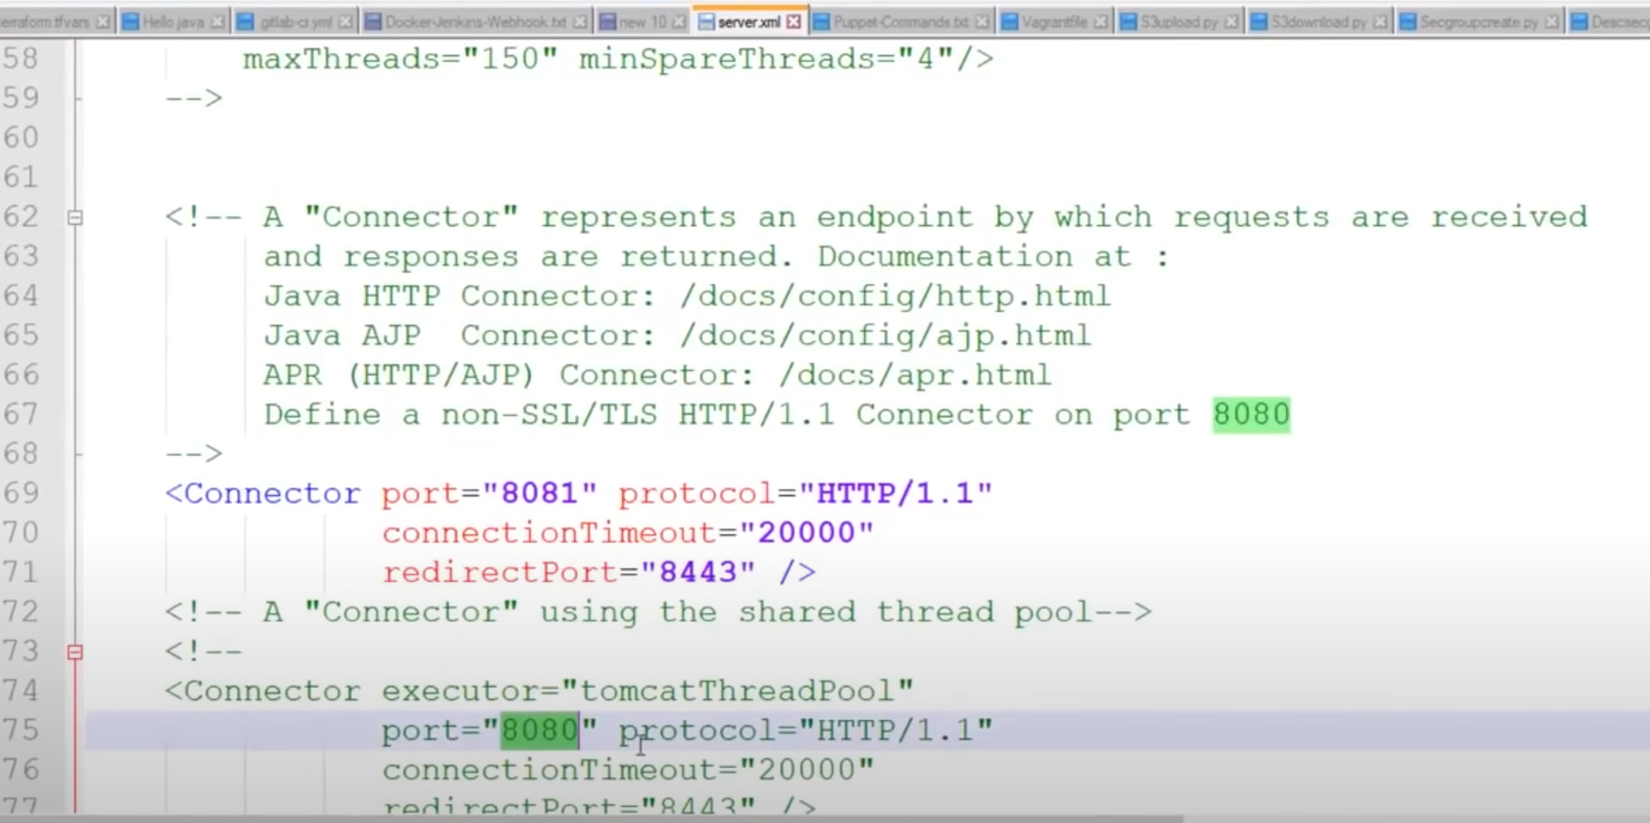

Also create the authentication credentials in “tomcat-users.xml”

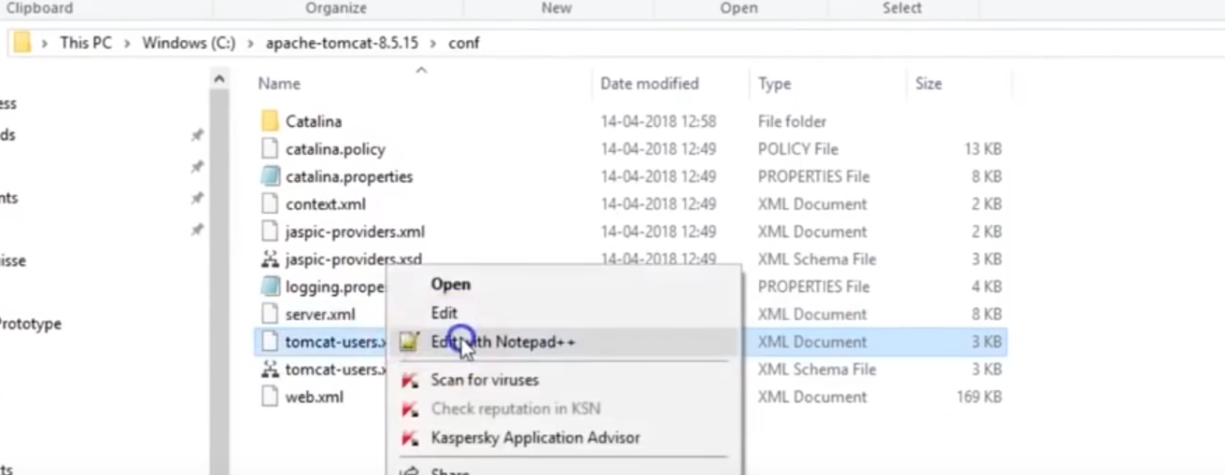

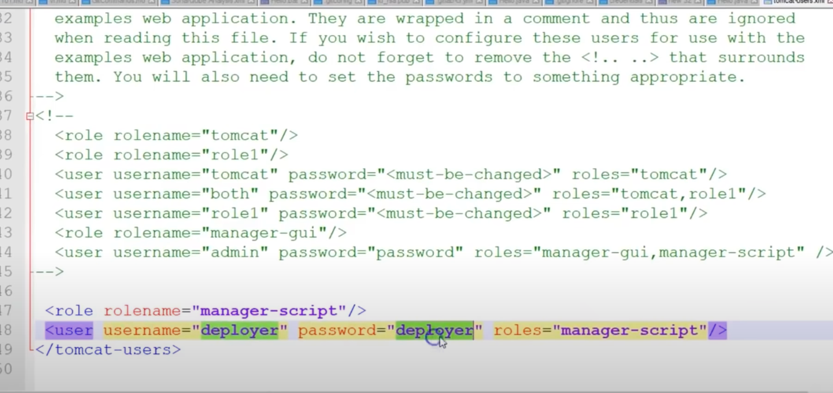

1. Install GitHub plugin as well
2. Create a job -> Select ***New Item*** in Jenkins console

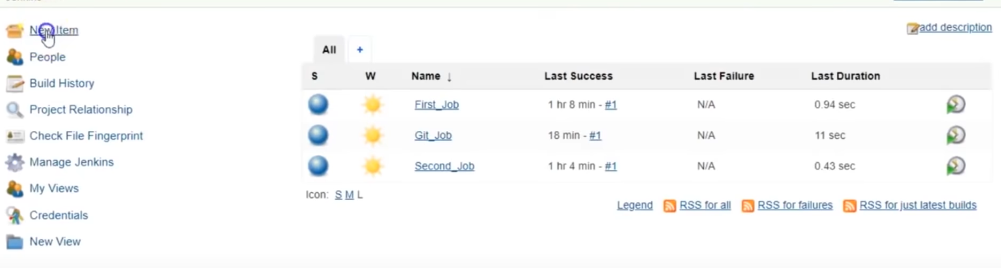

1. Give your project a name “Mvn_Web_App”

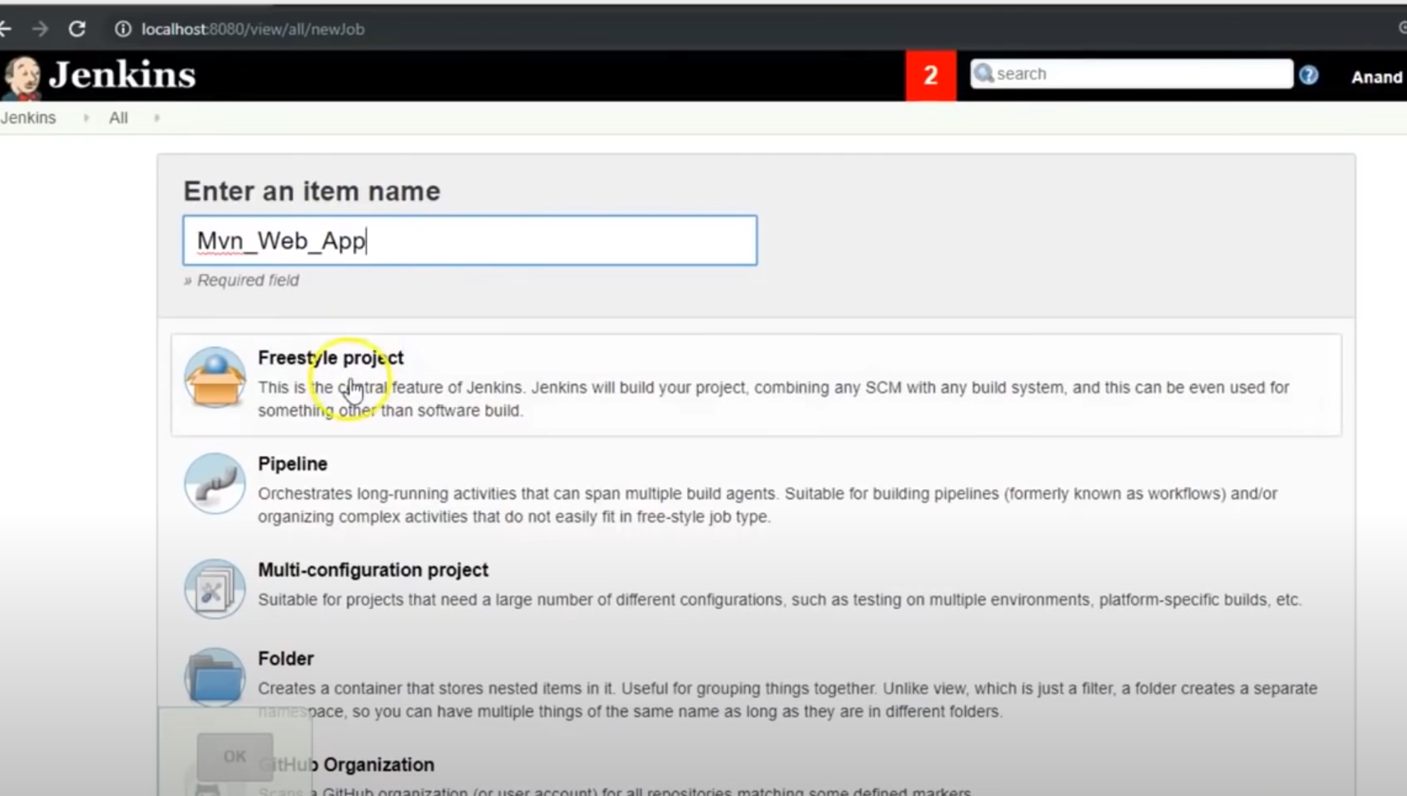

1. Select the type of project. ***Freestyle Project*** in this case.
2. Click OK.
3. Set GIT Repository in ***Source Code Management*** segment
   1. Give Repository link and add credentials in the Add section
   2. Add branch if required

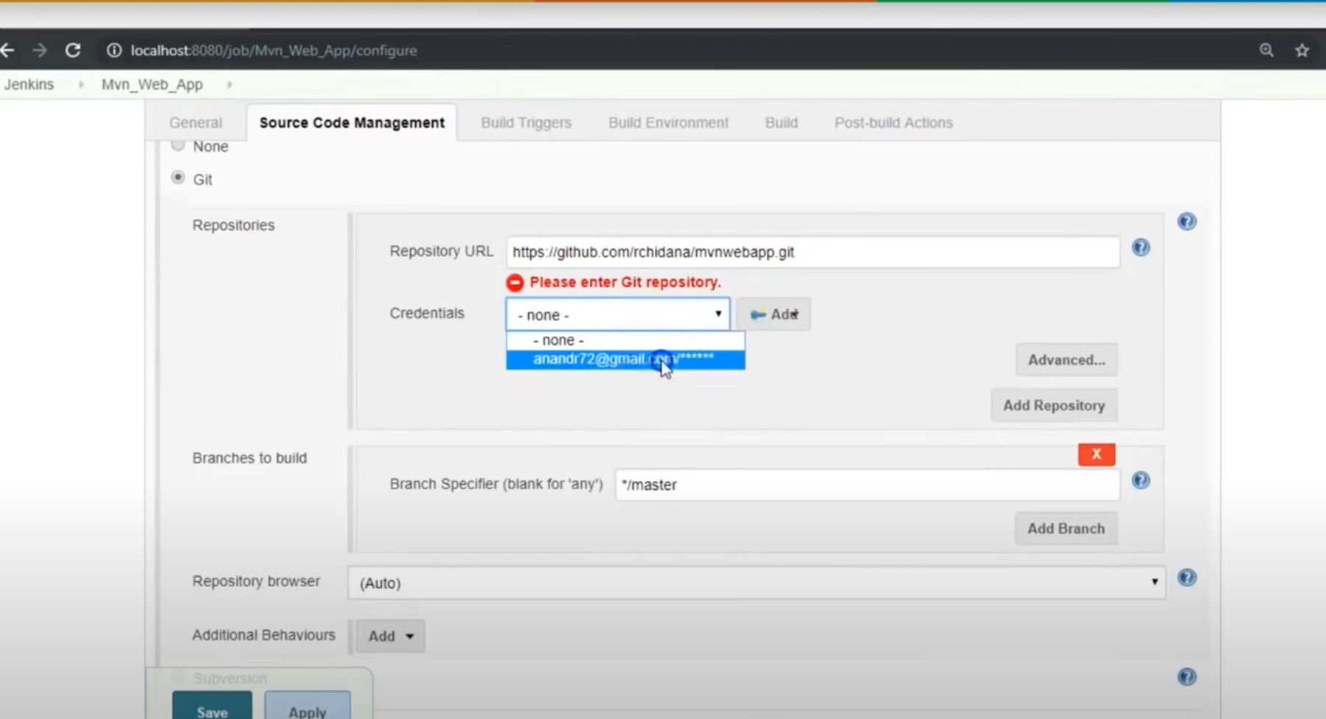

1. In the ***Build*** section, select ***Execute Windows batch command***

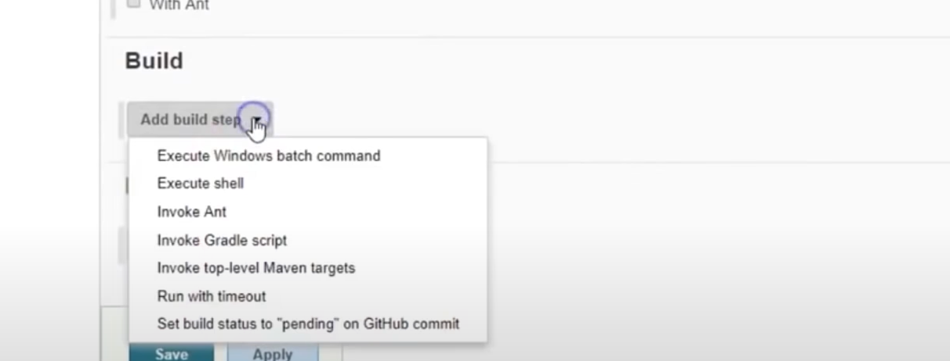

1. Type “mvn package” to create a war file.

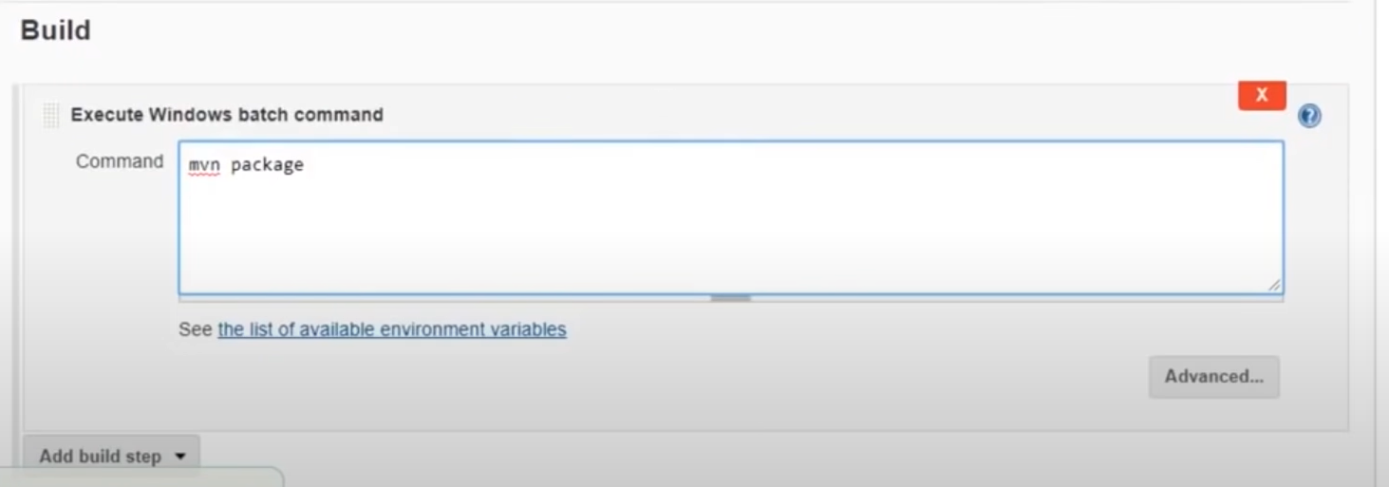

1. Save the configuration
2. Select ***Build Now*** to build the project

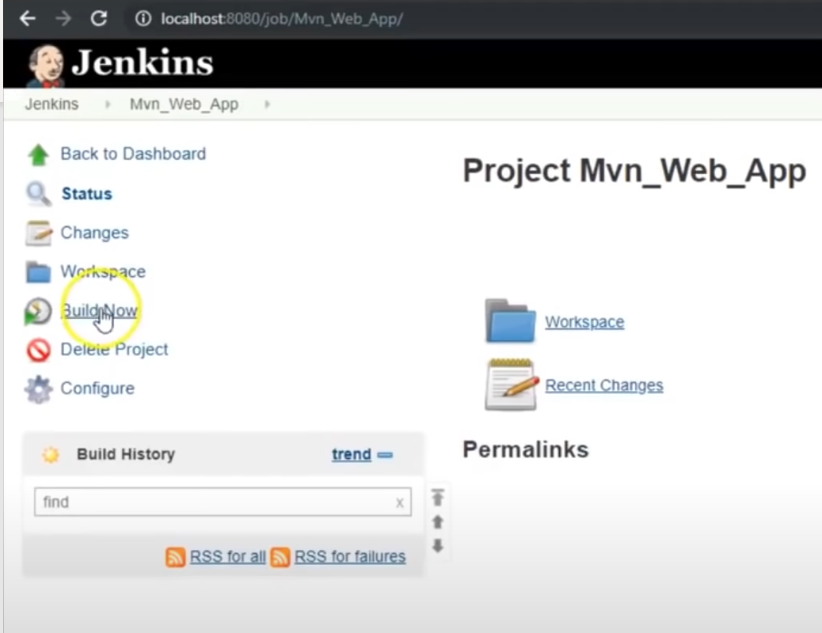

1. Wait for the project to get built. Check on ***Console Output*** for the output

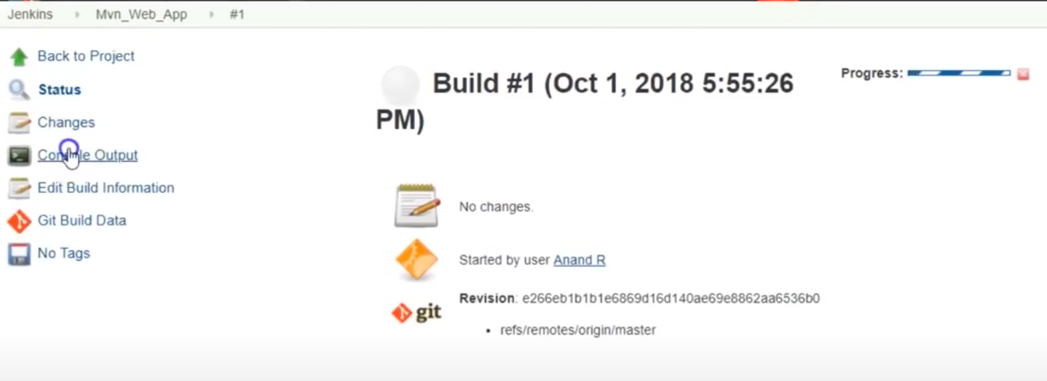

1. You can see the output in the console. Once the project has been successfully built, you can find the location of the war file in the console output.

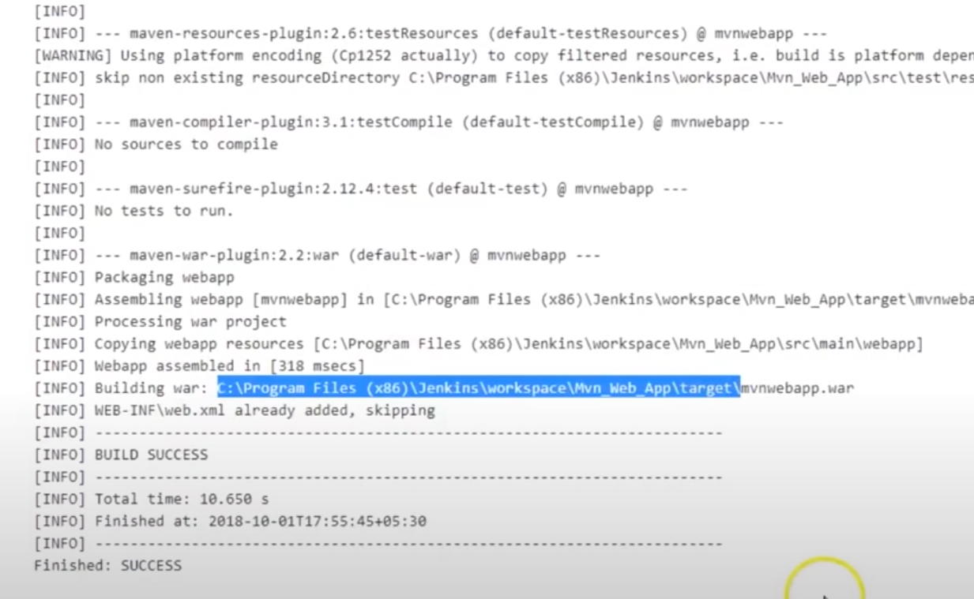

1. Now grab the war file and deploy it in Tomcat server.
2. Install ***Deploy to container*** plug-in for deploying the war file

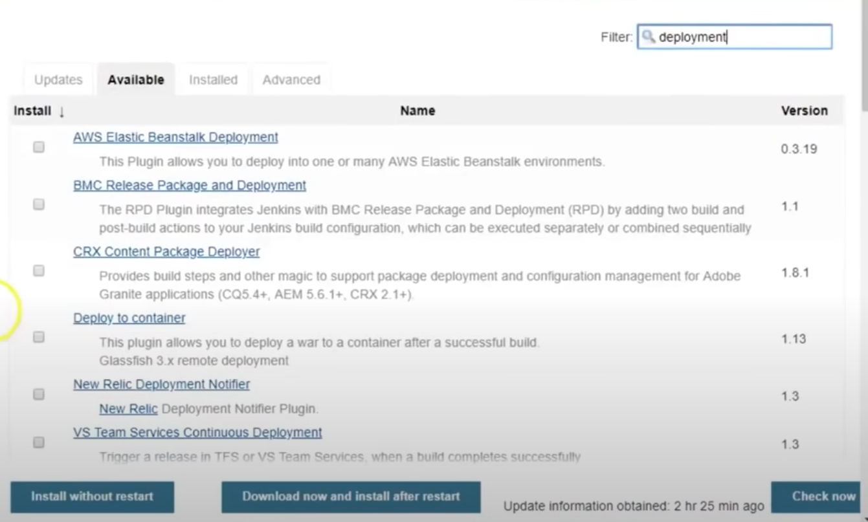

1. After installing the plug-in, go to the project building steps and add ***Post-built action*** and select ***Deploy war/ear to a container.*** 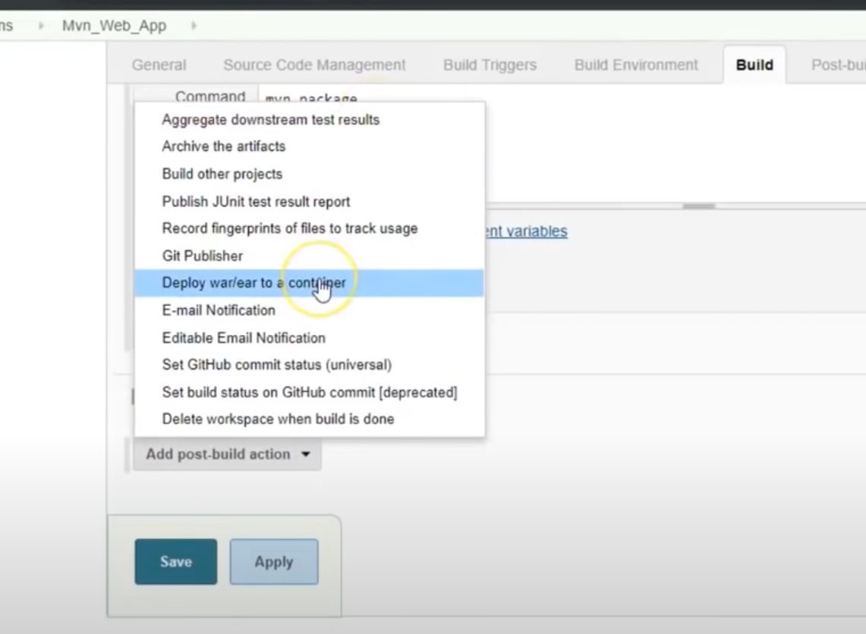
2. Provide the necessary details
   1. Select ***WAR/EAR files*** as “**/*.war” to select all the .war files.
   2. Add URL pathname “mvnwebapp” in the ***Context path***.
   3. Select “Tomcat 8.x” as we are using Tomcat version 8 in ***Container.***
   4. Provide Tomcat credentials which have been configured in Step 2.
   5. Provide the URL link <http://localhost:8081/> in ***Tomcat URL.*** 8081 was configured as the port for Tomcat.

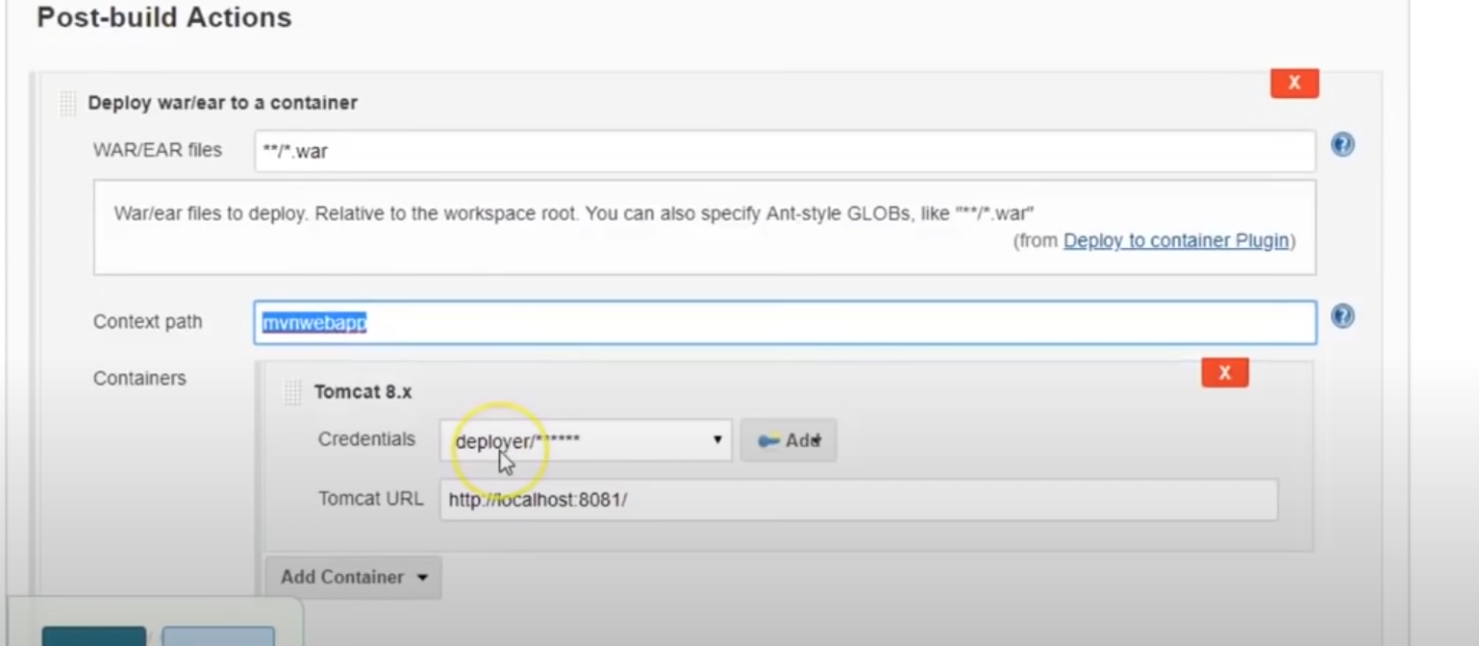

1. Then select ***Build Now*** again. This will build and deploy the app.
2. Check the ***Console Output***

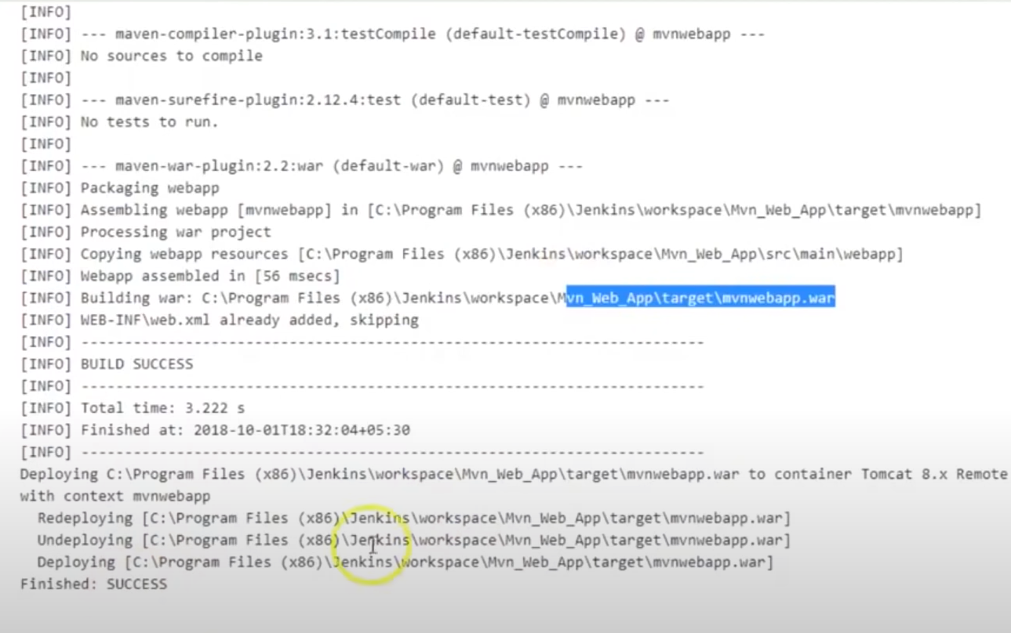

1. URL -> [http://localhost:88081/{context](http://localhost:88081/%7bcontext) path}

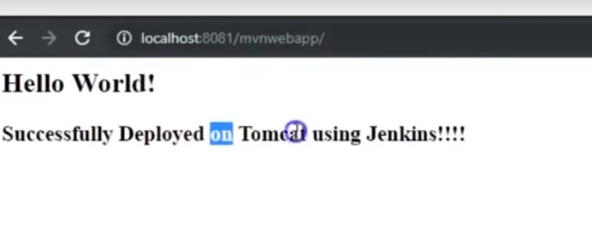

**DISTRIBUTED BUILD or MASTER-SLAVE SERVER**

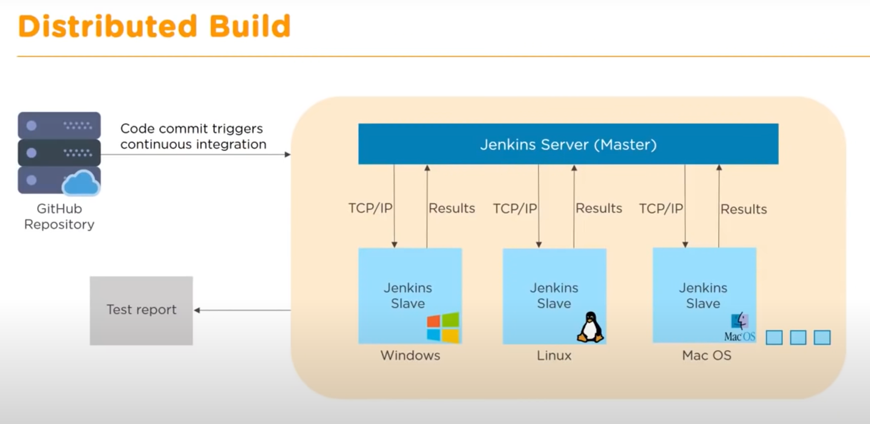

**HOW TO CREATE AND AGENT NODE IN JENKINS:**

* Jenkins uses JNLP so that the master can speak with the agent/slave.
* JNLP – Java Network Launch Protocol: Used for Client-Server (Master-Slave) conversation.
* Before configuring the agent node, we need to enable JNLP first.
* To enable JNLP
  1. Go to ***Configure Global Security***

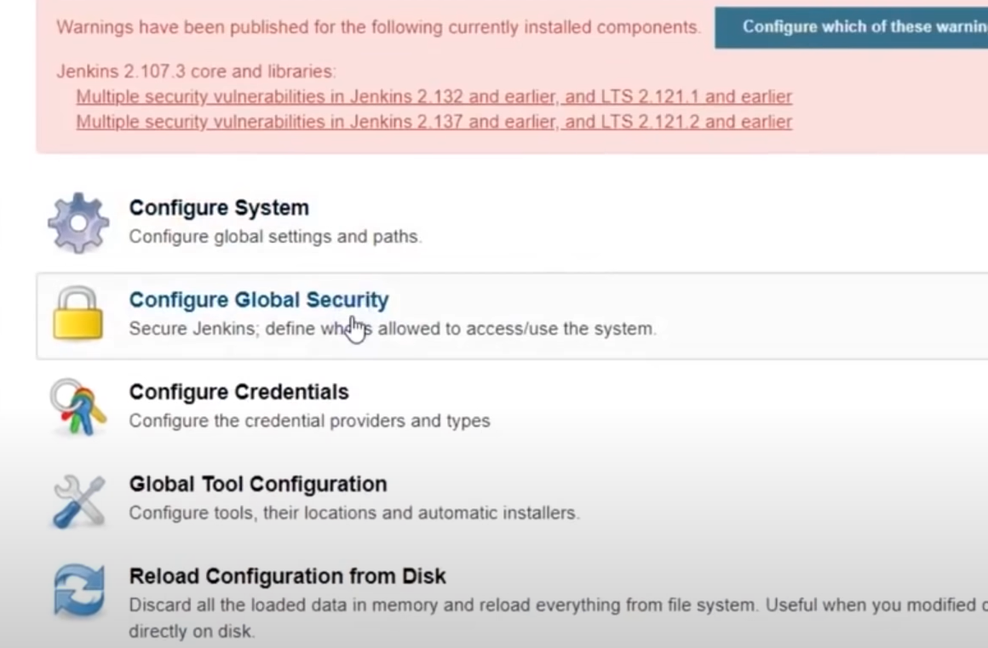

* 1. Enable the ***Agents*** configuration. By default, it would be disabled.

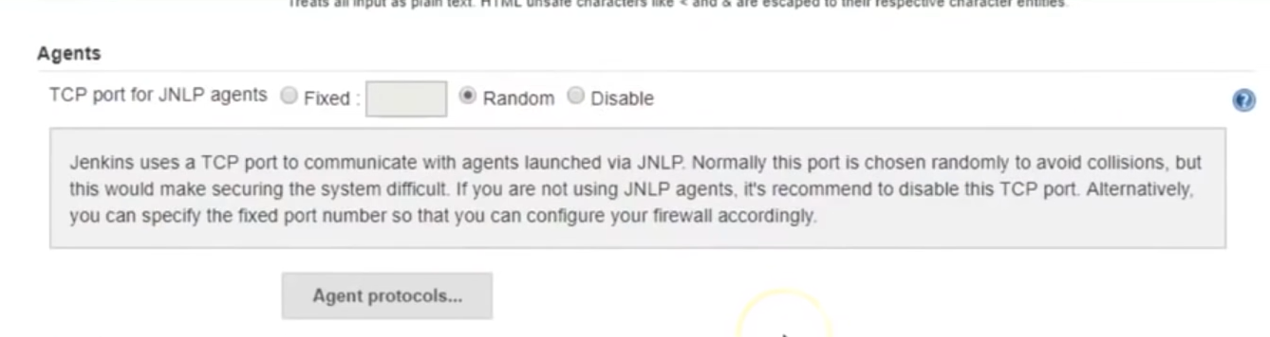

* 1. Save the configuration.
* After enabling the JNLP, we can create the Agent node.
  1. Go to ***Manage Jenkins*** to create an agent(slave).

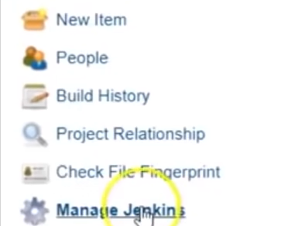

* 1. Go to ***Manage Nodes***

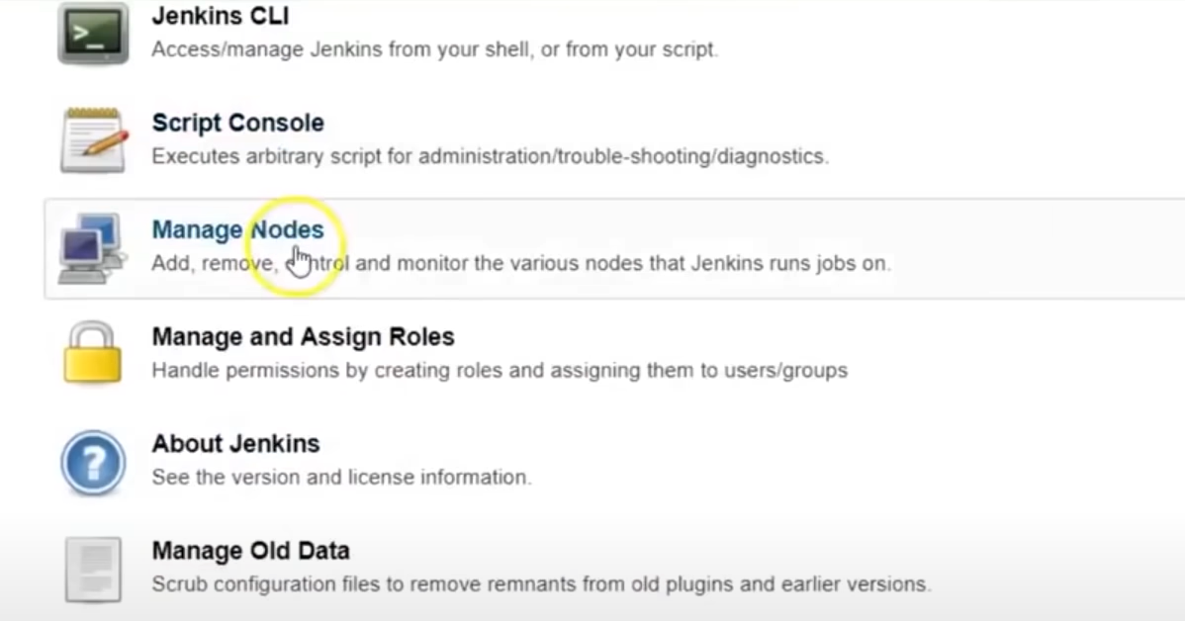

* 1. Click on ***New Node***

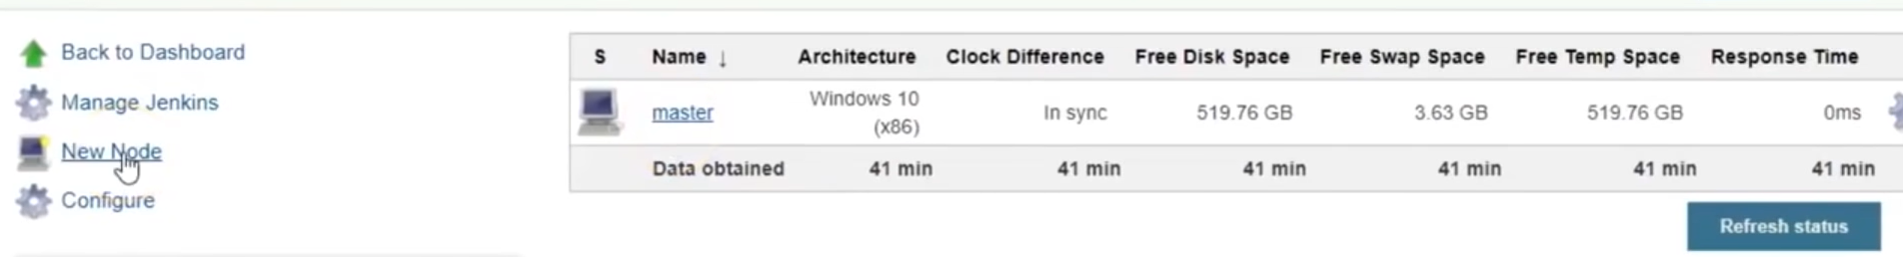

* 1. Give the node a name “Windows_Node” and select ***Permanent Agent*** and click ***OK.***

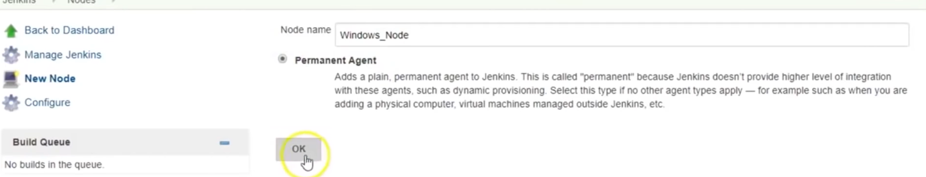

* 1. Complete the details as asked on screen

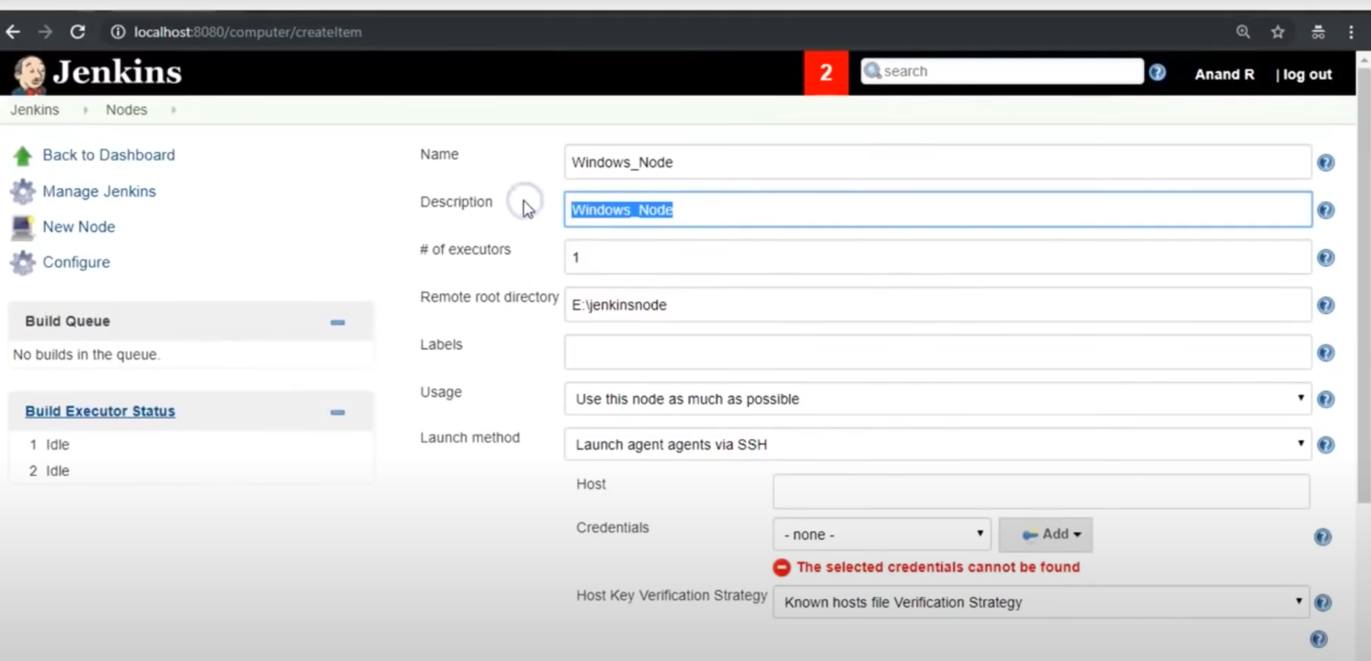

* 1. The ***Remote root directory*** is the location of the slave node. It can be either in a different drive or a different system, but not the same directory as the master node.
  2. Give the node a ***Label***, so that we can delegate the tasks to the node based on the label name.
  3. Select ***Only build jobs with label expressions matching this node*** in ***Usage*** as we want the slave to work only for the jobs with matches the labels, and not all the jobs. This way we can segregate nodes for like Windows, Mac, etc.
  4. Select ***Launch agent via Java Web Start*** in ***Launch method*** as we are using JNLP.

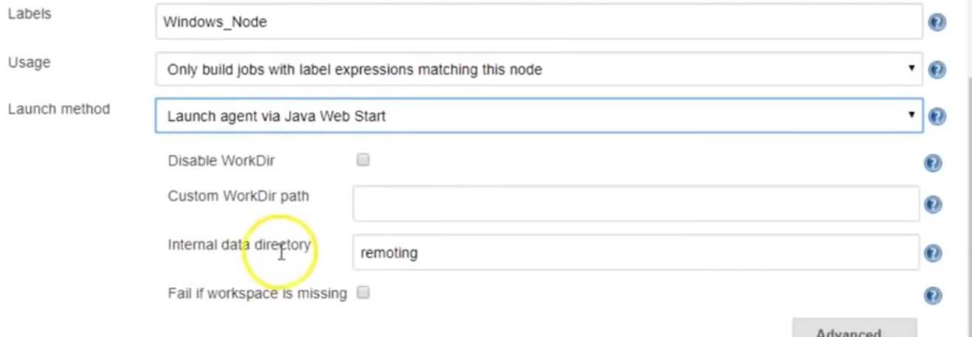

* 1. Select ***Keep this agent online as much as possible*** in ***Availability*** .

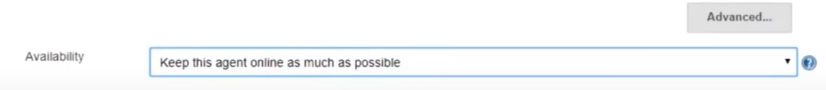

* 1. ***Save*** the configuration.
  2. You can see the slave node in Nodes section

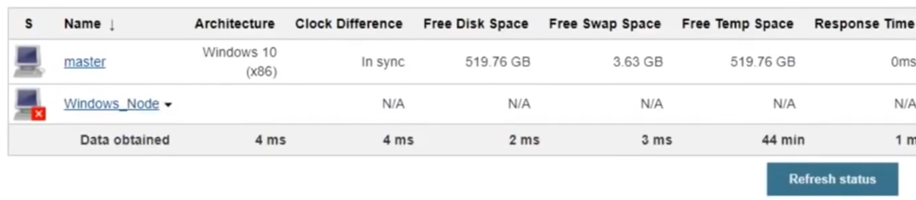

* 1. Click on the agent node “Windows_Node”

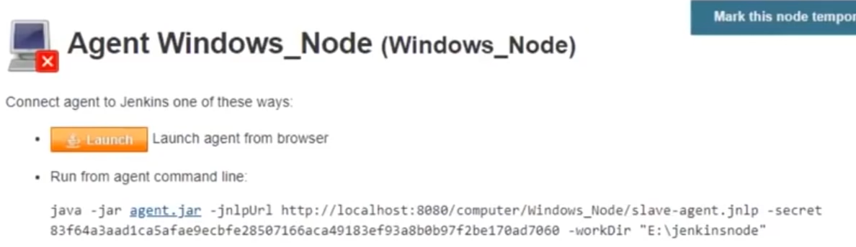

* 1. Download the agent.jar file in the machine that you want your slave to be in and save it in the directory that you had given earlier in ***Remote root directory*** in Step 9. Save the command line as well, as it will be required to run the agent.
  2. Open the cmd prompt in the ***Remote root directory*** and run the above command line.

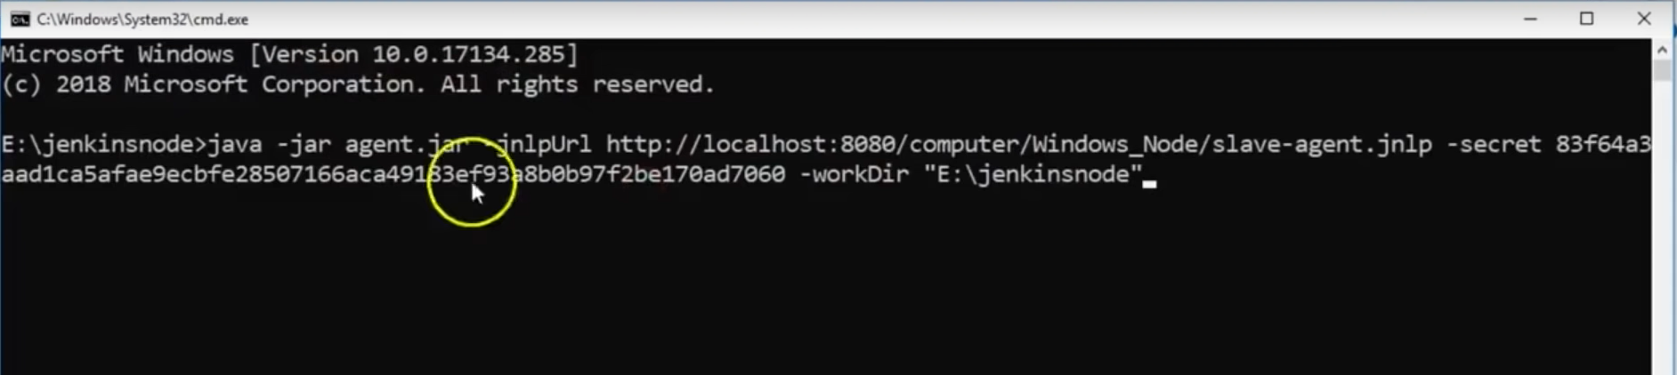

* 1. Press **Enter**.

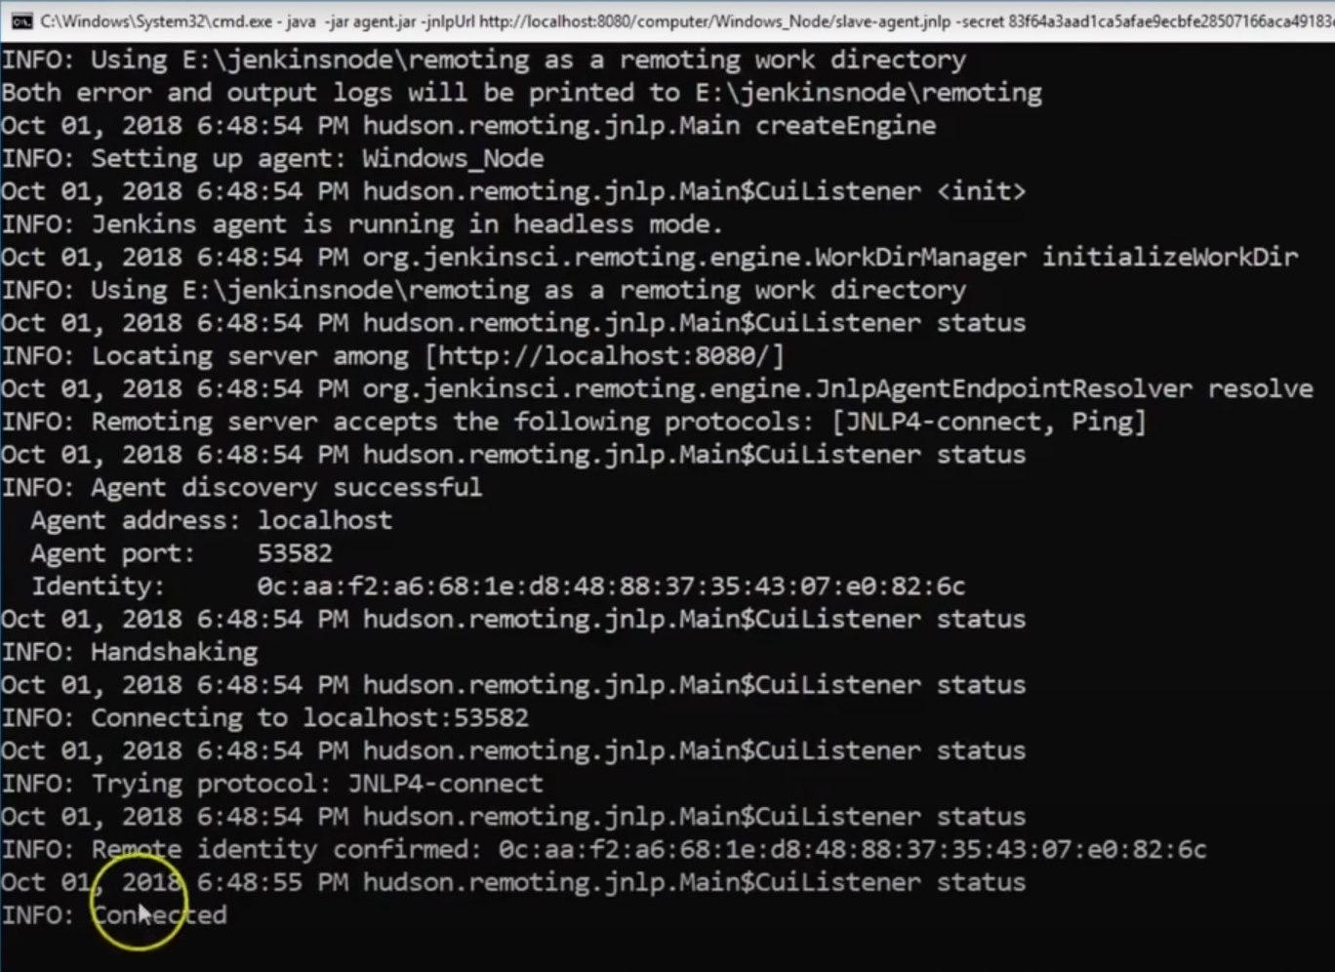

* 1. With this step, we have launched the agent.
  2. To use this agent for specific jobs, create a new job and check on ***Restrict where this project can run*** and provide the ***Label Expression*** as the name of the Agent’s label“Windows_Node”.

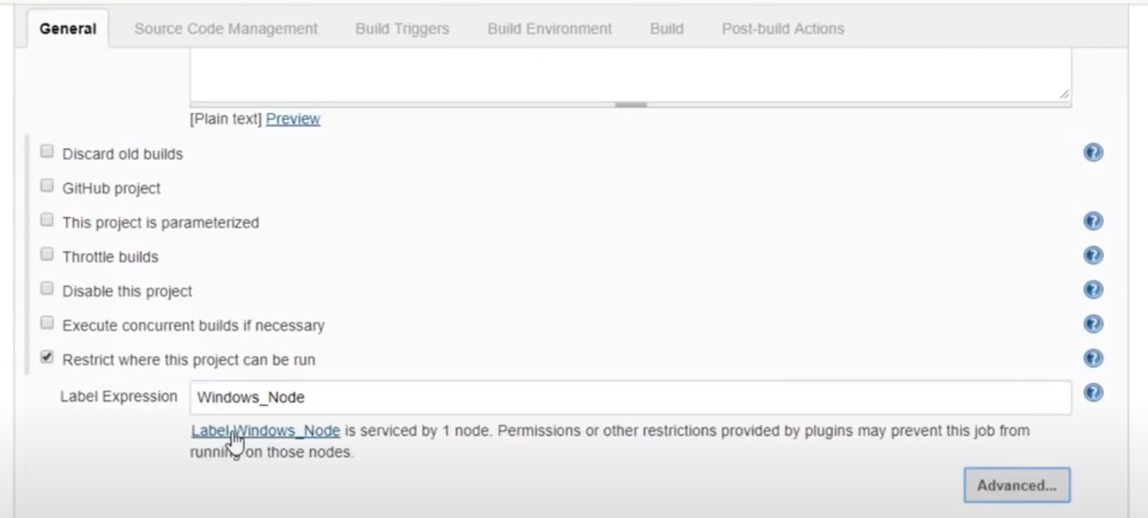

* 1. All the jobs which will be run by this agent node, we can see the folders created in the ***Remote root directory***.

**HOW TO CREATE THE BACKUP OF A CONFIGURATION**

* We might come across a situation where we have lost the configuration of our Jenkins due to some errors or corruption.
* To avoid creating the whole configuration settings again, we can create a backup of the current configuration and save it in local drive. By this method, we can ensure that our setting will have a safe copy and in case something goes wrong, we can retrieve the settings.
* Steps to create a backup of configuration:
  1. Go to ***Manage Plugins*** and install a backup plugin

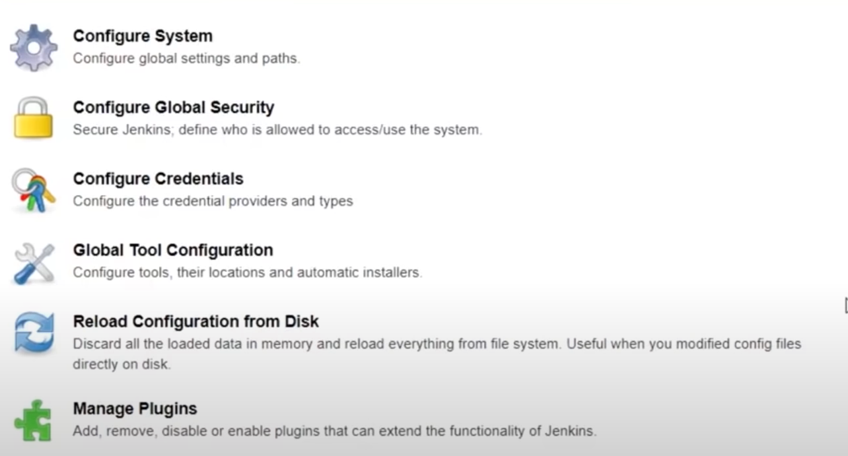

* 1. 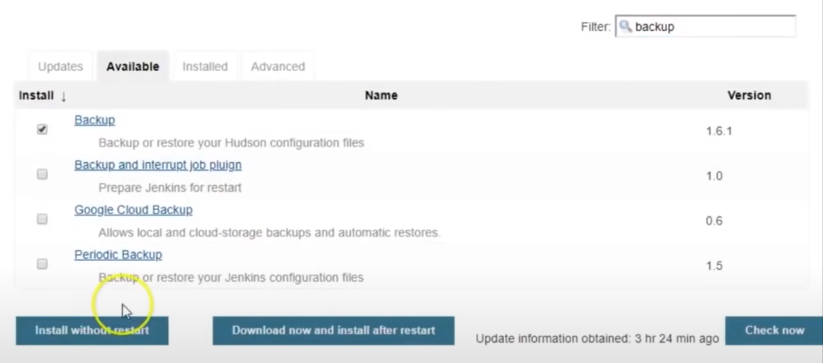
  2. Go to ***Backup Manager***

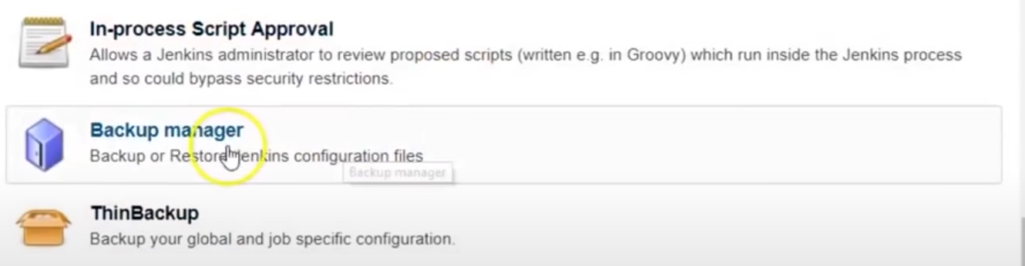

***You will see this option only after installing a backup plugin.

* 1. Create the setup first by going to ***Setup.***

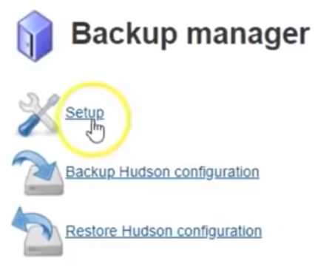

* 1. Configure the setup

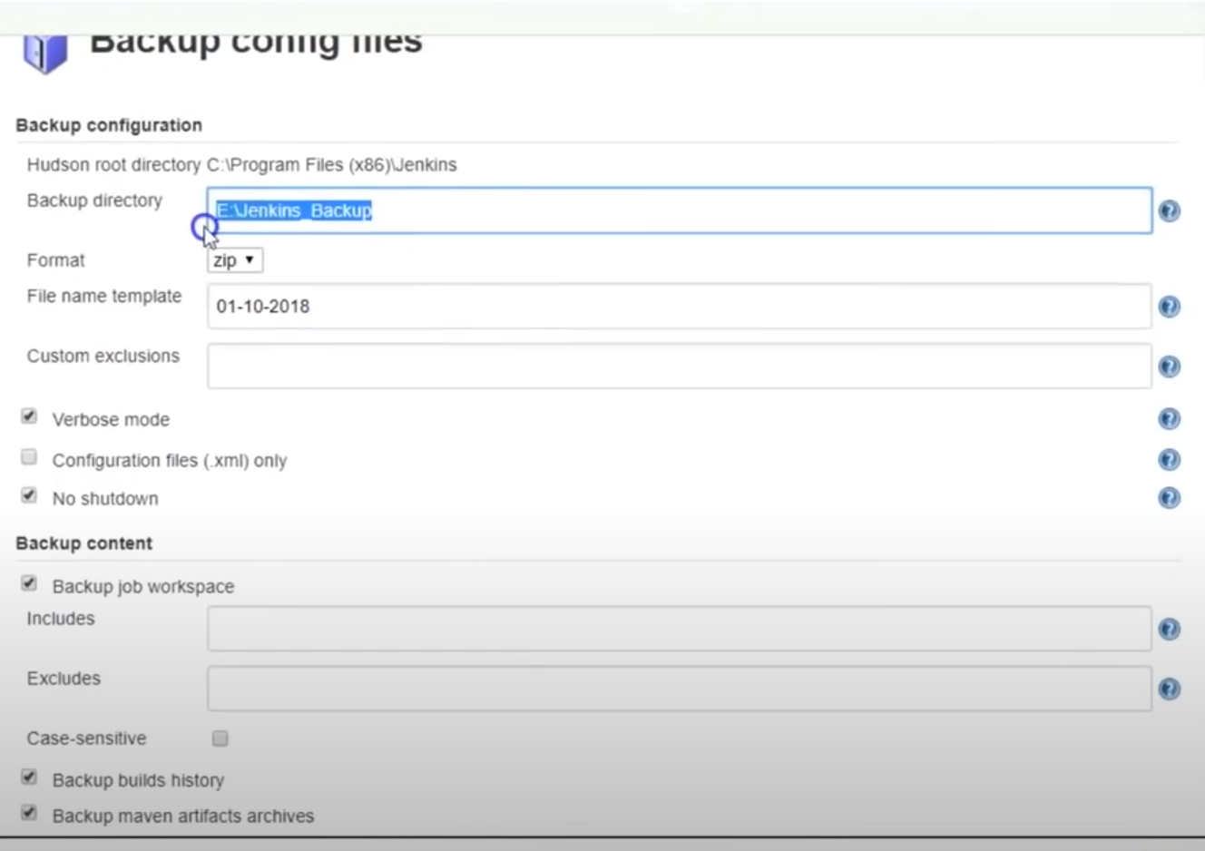

* 1. ***Save*** the settings.
  2. Go to ***Backup Hudson configuration*** to create a backup copy which will be saved in .zip format in the backup directory selected in Step 5.
  3. After clicking ***Backup Hudson configuration*** a backup copy will be created.

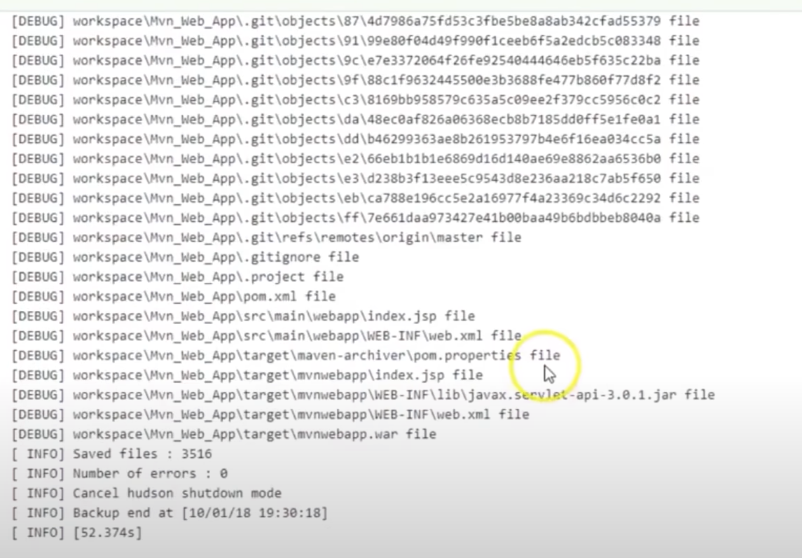

* 1. To load a backup copy, click on ***Restore Hudson configuration***.

**WHAT IS PIPLEINE IN JENKINS?**

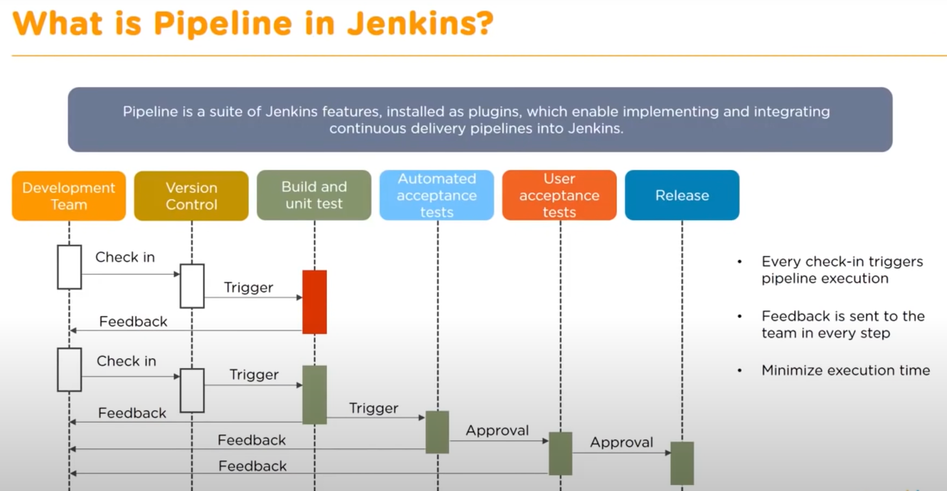

* We can create a pipeline using Groovy script
* An example of scripted pipeline is given below:

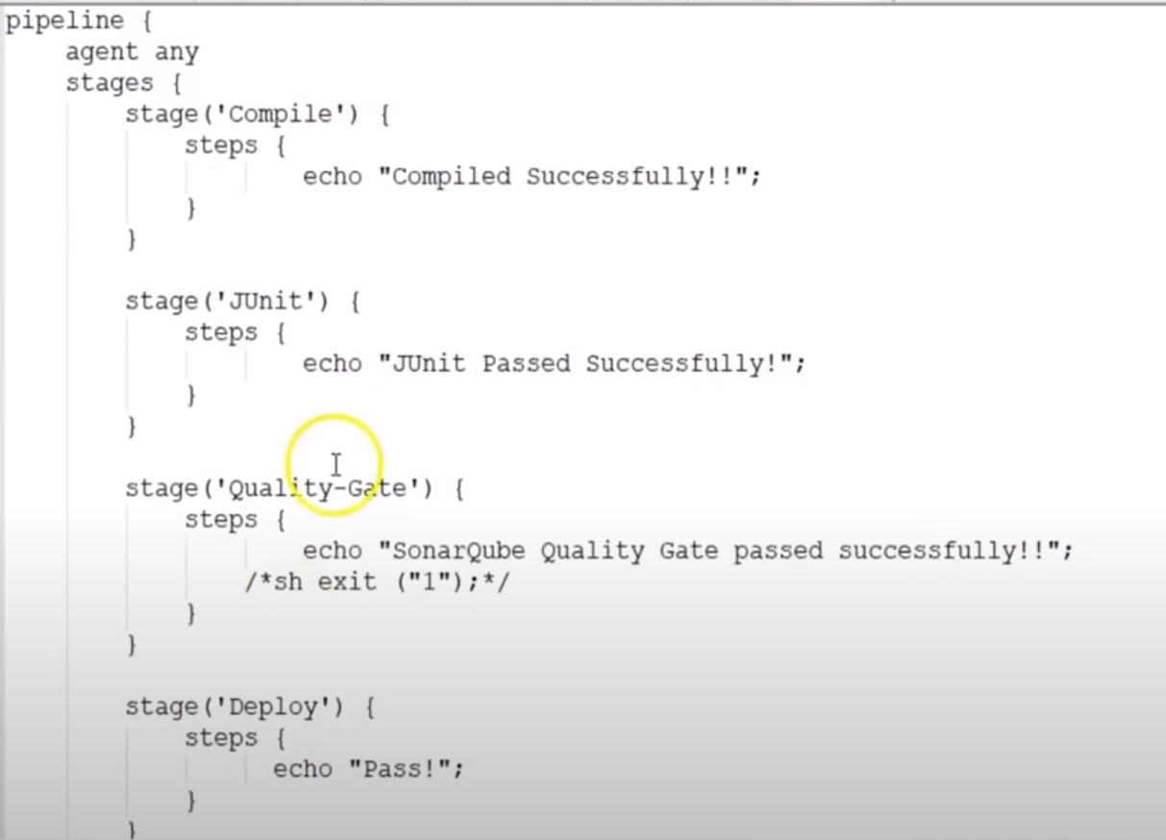

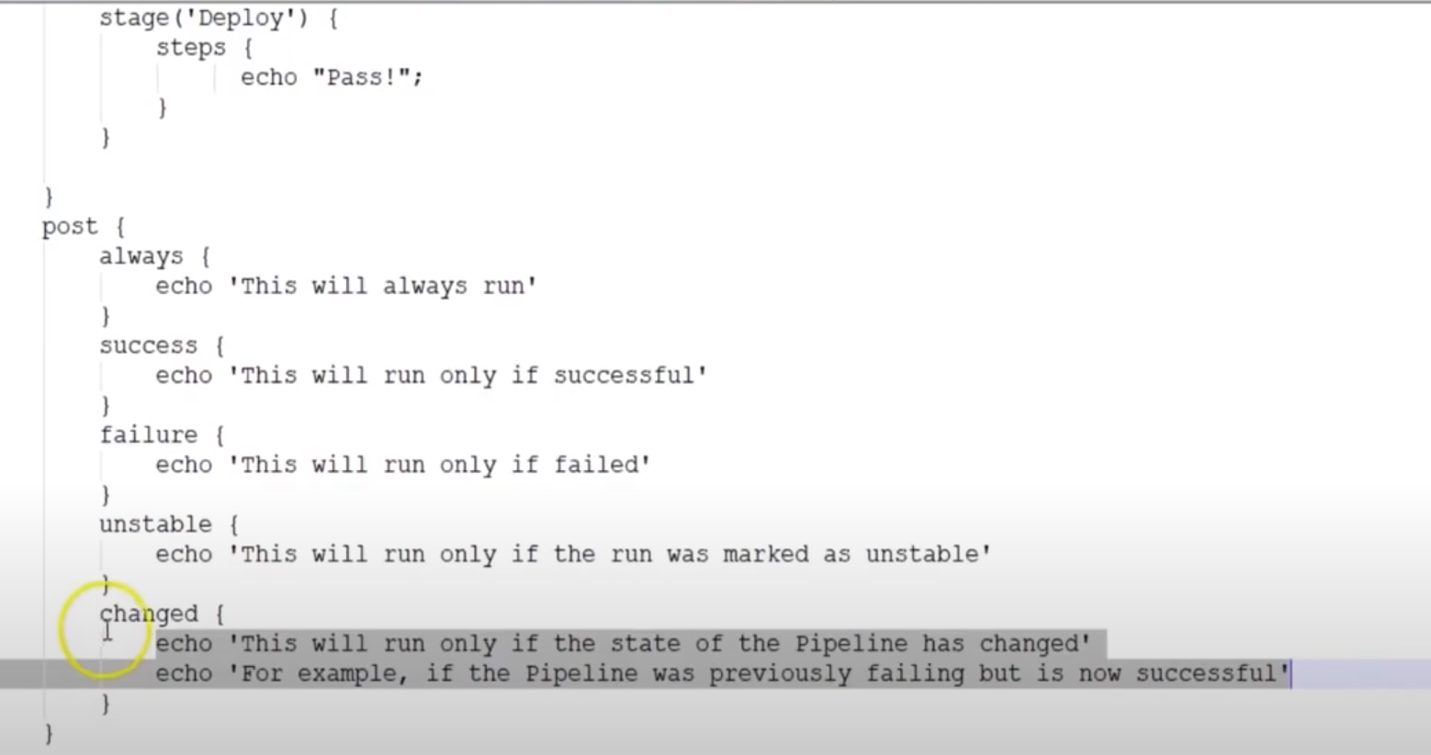

**STEPS TO CREATE A SCRIPTED PIPELINE IN JENKINS:**

1. To create a scripted pipeline in Jenkins, go to ***Create Job***, give your pipeline a name “Scripted_Pipeline”, and select ***Pipeline***.

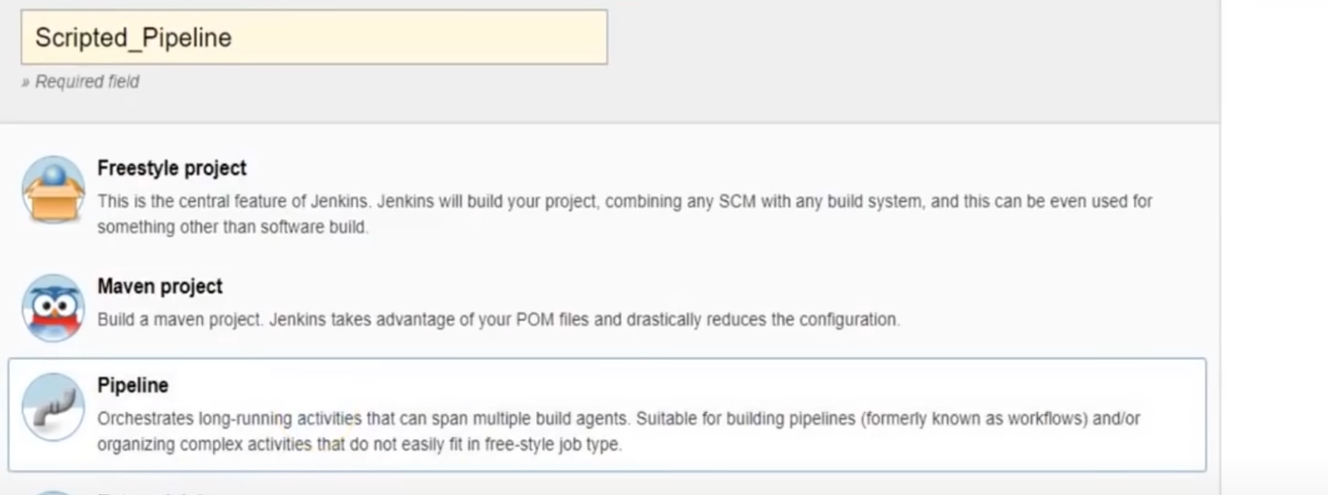

1. Click ***OK***.
2. Write the script in ***Pipeline*** section.

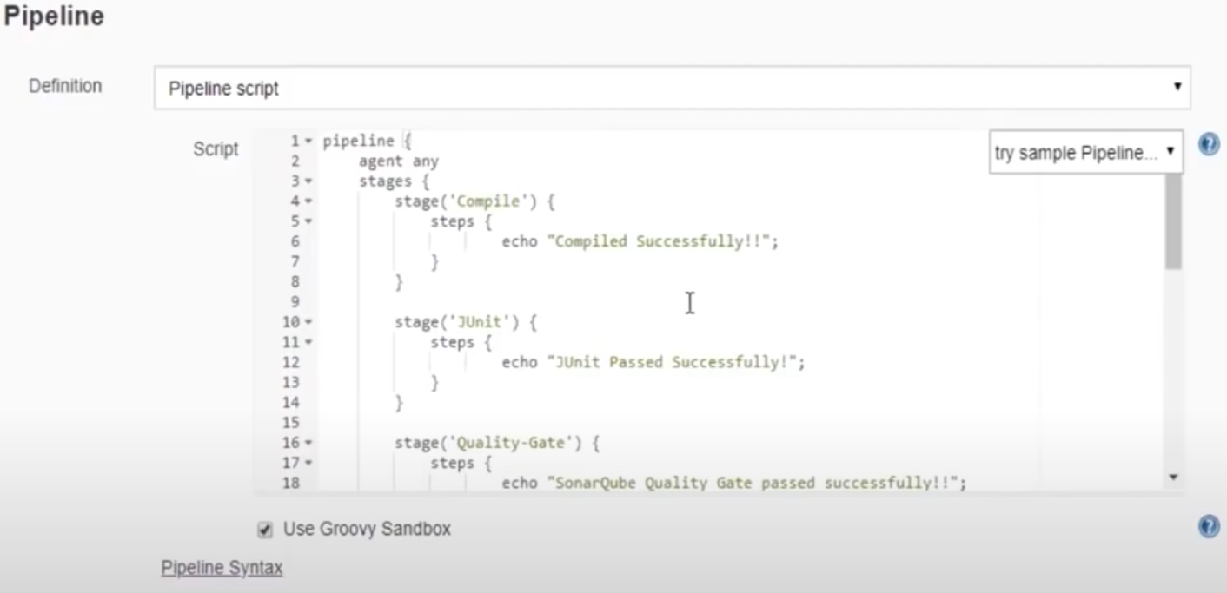

1. Click on ***Save***.
2. Build the job/pipeline using ***Build Now***.

**TO GRAB A SCRIPTED PIPELINE FROM GITHUB REPOSITORY AND RUN THAT SCRIPT:**

* It is possible to have your scripts stored in a git repo, and we can use that repo directly to fetch the scripts from there and run in Jenkins.
* Steps to fetch a script from GitHub
  1. To fetch a scripted pipeline from GitHub, go to ***Create Job***, give your pipeline a name “Scripted_Pipeline_GitHub”, and select ***Pipeline***.

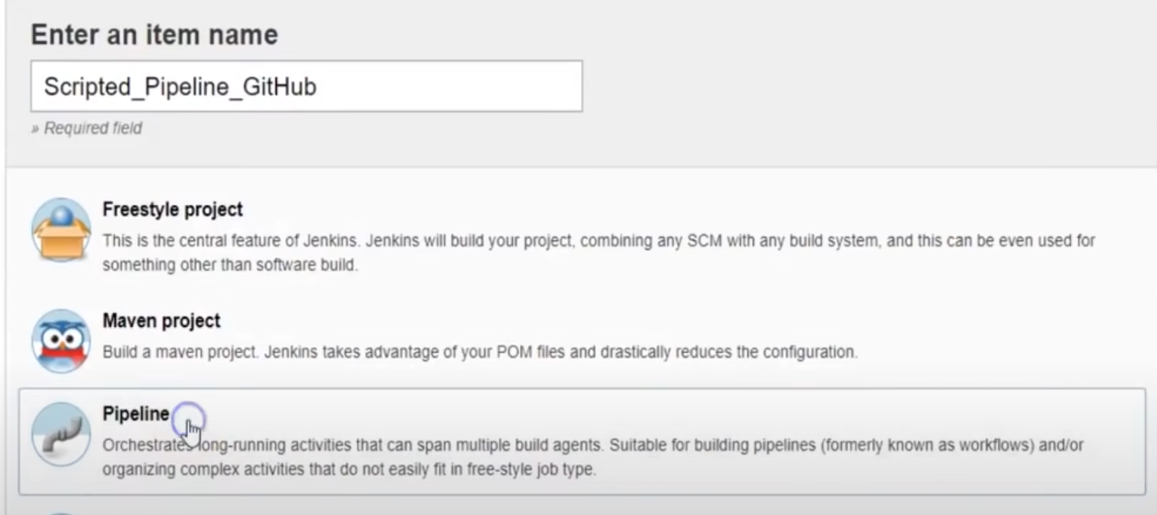

* 1. Click ***OK.***
  2. In the ***Pipeline*** section, select ***Pipeline Syntax***.

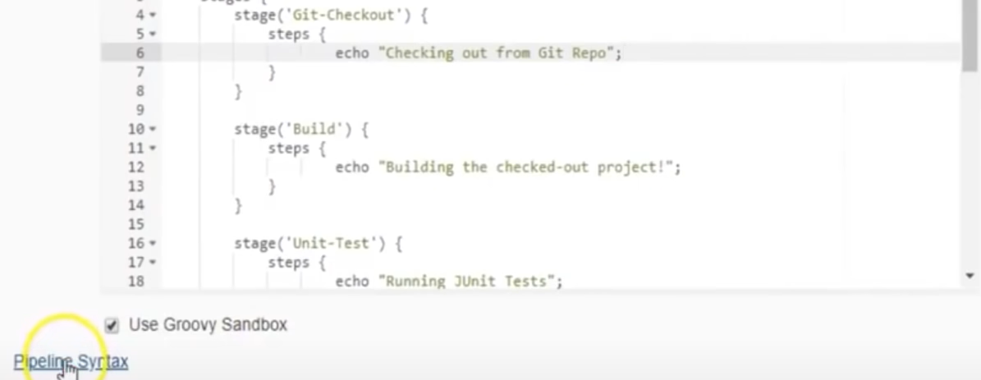

* 1. Select ***git:Git*** in ***Steps***.
  2. Specify the repository URL in ***Repository URL*** and provide the login credentials in ***Credentials***.

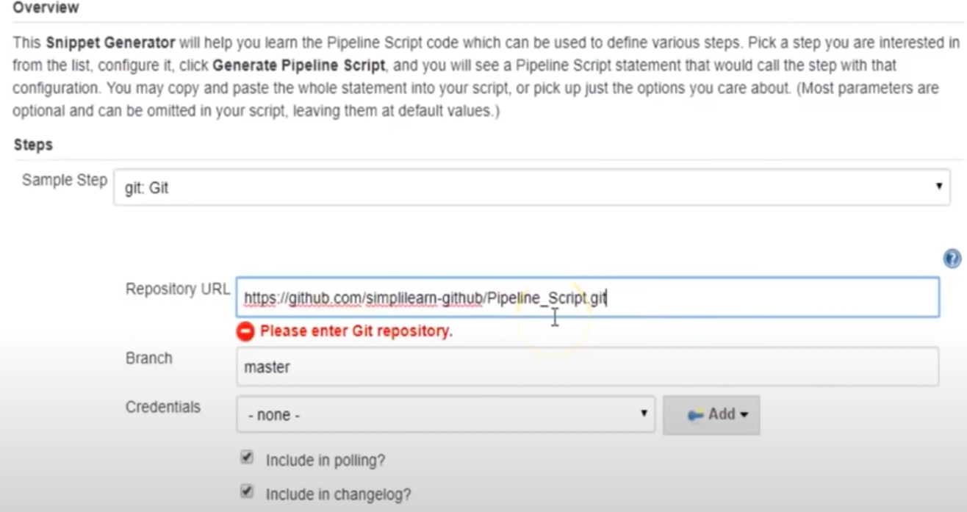

* 1. Click on ***Generate Pipeline Script***, this will generate the script for the repo and paste it in the original script -> Line no. 7.

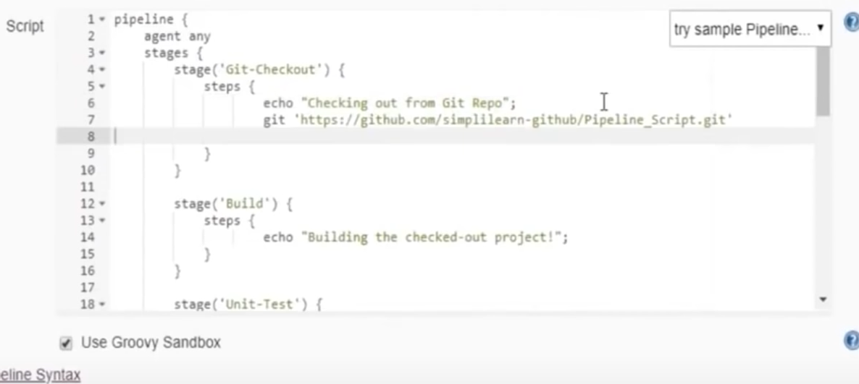

* 1. Similarly, paste the scripts of the batch files from the repo that you want to run.
  2. Select ***bat: Windows Batch Script*** in ***Steps***. Type the name of the batch file in ***Batch Script***.
  3. Click on ***Generate Pipeline Script***.

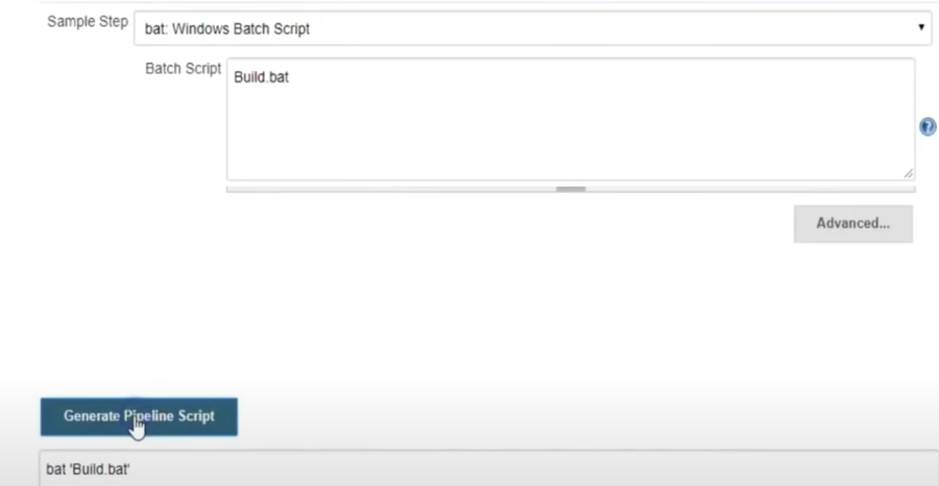

* 1. Add the script line in the original script.

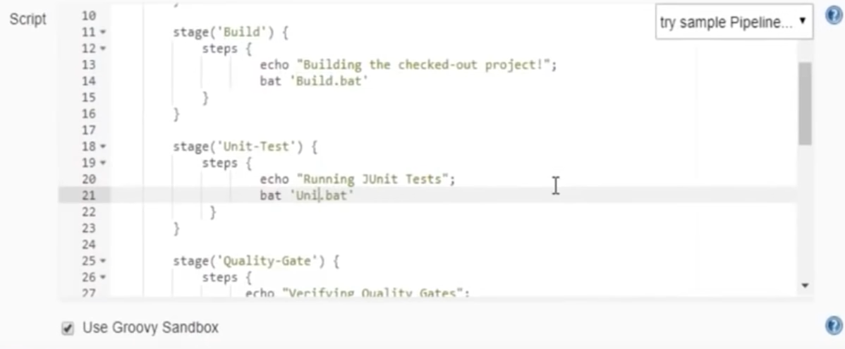

* 1. Click on ***Save***.
  2. Click on ***Build Now*** to run the pipeline.

**DELEGATE THE SCRIPTED PIPLEINE TO AN AGENT**

1. Make sure that the agent is up and running.
2. Create a new job named “Agent_Scripted_Job” and select ***Pipeline***.
3. In the script, instead of agent any, put the label of the agent that you want the script to run

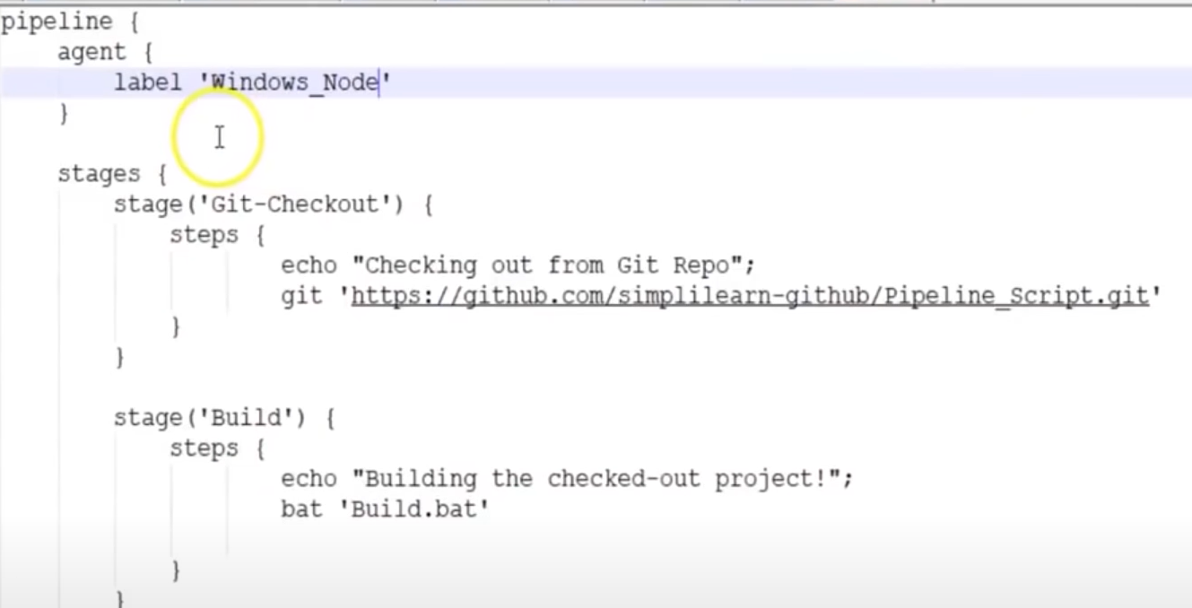

1. The rest of the steps are same as above.

**TYPES OF PIPELINES:**

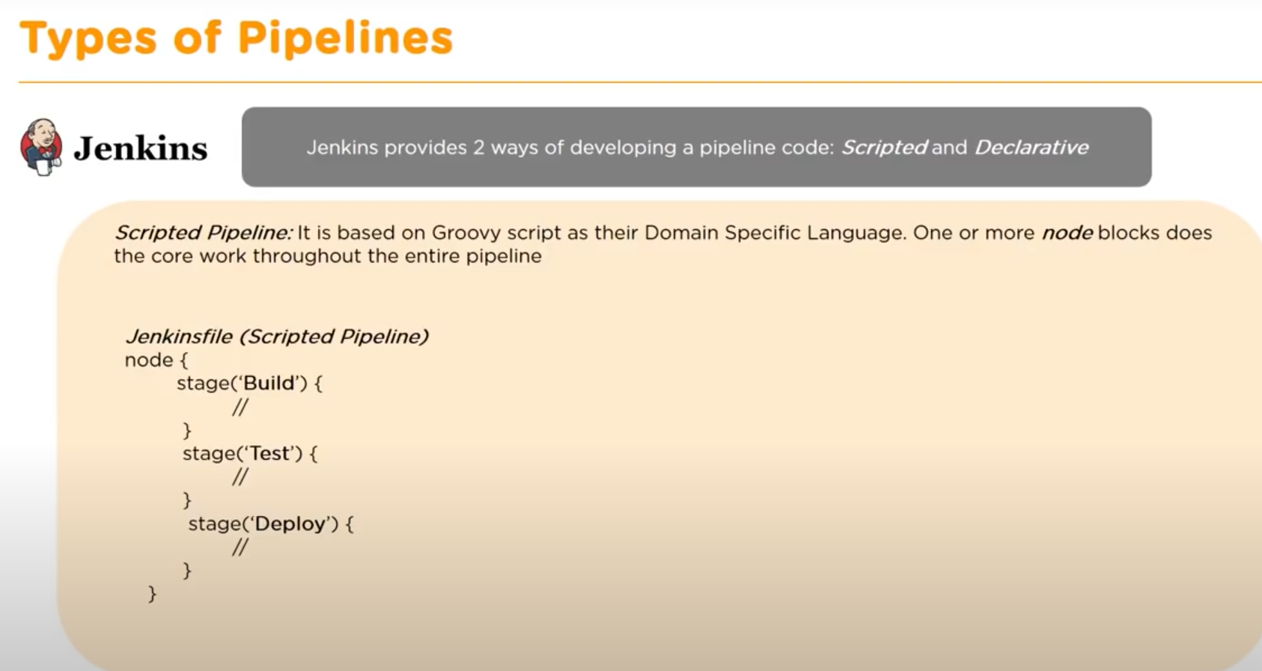

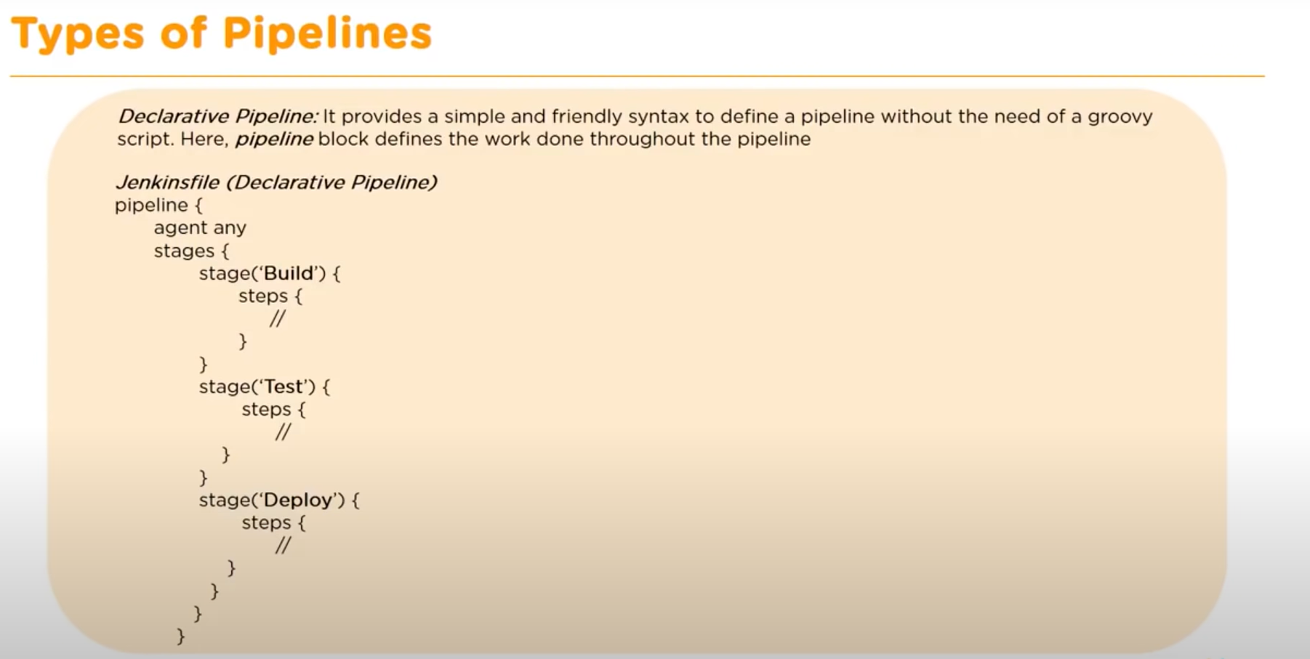

**Install Jenkins in AWS EC2 instance**

Use <https://github.com/yeshwanthlm/installing-jenkins> for reference

* Install jdk in the system
  + sudo apt install openjdk-11-jdk
* Install Jenkins
  + curl -fsSL https://pkg.jenkins.io/debian-stable/jenkins.io.key | sudo tee \

/usr/share/keyrings/jenkins-keyring.asc > /dev/null

* + echo deb [signed-by=/usr/share/keyrings/jenkins-keyring.asc] \

https://pkg.jenkins.io/debian-stable binary/ | sudo tee \

/etc/apt/sources.list.d/jenkins.list > /dev/null

* + sudo apt-get update
  + sudo apt-get install jenkins
* To start Jenkins server
  + sudo systemctl start jenkins.service
* To check if Jenkins is running or not
  + sudo systemctl status jenkins.service
* With Jenkins installed, we can proceed with adjusting the firewall settings. By default, Jenkins will run on port 8080.
* In order to ensure that this port is accessible, we will need to configure the built-in Ubuntu firewall (ufw). To open the 8080 port and enable the firewall, use the following commands:
  + sudo ufw allow 8080
  + sudo ufw enable
* Once done, test whether the firewall is active using this command:
  + sudo ufw status
* Open Jenkins in your browser public_IP_of_the_instance:8080
  + 13.127.147.83:8080

No need to use the above steps, just enable the port in security groups. Just enable TCP 8080 in inbound rules

**Deploying maven project on Jenkins:**

* Install plugin *Deploy to Container* in Jenkins.
* Jenkins pipeline

pipeline {

agent any

// without mentioning the tools, the mvn command won’t work

tools {

maven 'mvn' //mvn as mentioned in Global Tool Configuration

jdk 'java' //java as mentioned in Global Tool Configuration

}

stages {

stage('git-checkout') {

steps {

sh "echo 'in Git checkout'"

}

}

stage('Check for Maven') {

steps {

sh '''

echo $JAVA_HOME

echo $MAVEN_HOME

echo $M2_HOME '''

}

}

stage('Check Files') {

steps {

sh ''' echo 'In Check Files stage'

ls'''

}

}

stage('Build') {

steps {

sh '''

cd /var/lib/jenkins/workspace/Mvn_Web_Git_Pipeline/java-hello-world-webapp/

pwd

mvn clean install

'''

}

}

}

post {

success {

echo 'Pipeline built successfully!!!'

deploy adapters: [tomcat8(credentialsId: '2f6c95f9-e393-4d26-873e-20b472c42081', path: '', url: 'http://13.232.105.14:8080/')], contextPath: 'helloWorldWebApp', onFailure: false, war: '**/*.war'

}

failure {

echo 'Pipeline broken!!!'

}

}

}

* It is mandatory to make the username and password in tomcat-users.xml file.
* Also, comment out

“<Valve className="org.apache.catalina.valves.RemoteAddrValve" allow="127\.\d+\.\d+\.\d+|::1|0:0:0:0:0:0:0:1" />” in context.xml (location – “/opt/tomcat/apache-tomcat-8.5.85/webapps/manager/META-INF/’) as it’ll restrict the deployment otherwise.

* To see the deployed project, go to IPAddress:8080/contextPath

**Jenkins Shared Libraries:**

* In case you want to use some parameters in a shared library, you can’t directly use

parameters {

string (defaultValue: ‘ ’, description: ‘ ‘, name: ‘ ‘)

}

Instead, use properties and then parameters inside it. Like the example below

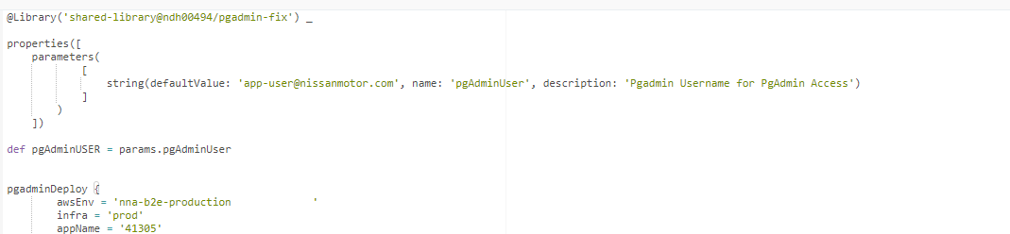

Then this property can be called inside the shared-pipeline

